BSO Tutorial Registration Services

BSO Tutorial

Registration Services

Contains the following lessons:

- Register User
  - Register User
  - Complete Phone Registration - For Appointed Representatives (AR), Consent Based Social Security Number Verification (CBSV), and Representative Payees (IRPA) Only
- Login
  - Login
  - Forgot Password - For Appointed Representatives (AR), Consent Based Social Security Number Verification (CBSV), and Representative Payees (IRPA) Only

- Logout

- Contact SSA

- Manage Account
  - View / Edit Account Info
  - Change Password - For Appointed Representatives (AR), Consent Based Social Security Number Verification (CBSV), and Representative Payees (IRPA) Only
  - Disable Account

- Manage Services
  - View / Edit Services
    - Remove Access to Services
  - Request New Services
    - Request Services Suite for Employers
    - Request Services Suite for Attorneys
    - Request Internet Representative Payee Suite
  - View Pending Services
    - Re-Request Activation Codes
  - Enter Activation Code(s)

- Manage Employer Information
  - Add Employer Information
  - Update Employer Information
  - Remove Employer Information

LESSON 1: REGISTER USER – Wage Reporting and Employer Services

Your BSO User ID and password is no longer used to access Business Services Online
(BSO) wage reporting services. You must use a Social Security online account, ID.me or
Login.gov credential to gain access to the BSO application.

Extra security is a requirement to access the following BSO wage reporting services:

- Wage file upload
- W-2/W-2C online
- AccuWage online
- Social Security Number Verification Service (SSNVS)
- View wage report name/SSN errors.

Follow the instructions below to register for a BSO User ID. After completing the steps, you can
request to wage reporting services.

STEP 1: Point your browser to the BSO Welcome page:
www.socialsecurity.gov/bso/bsowelcome.htm.

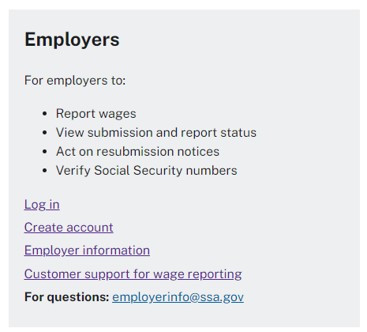

STEP 2: Select the Create account link on the BSO Welcome page from the Employers box
above.

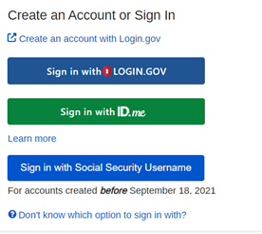

STEP 3: You must use a ID.me, Login.gov or a Social Security online credential to gain access
to the BSO application. Select Create an account with Login.gov to create an account. Please
note that you do not need to create a new Login.gov or ID.me credential specifically for SSA
purposes. You can use your existing Login.gov or ID.me credentials to log into SSA services too.
You will have the option to create a new BSO User ID or select an existing BSO User ID.

LESSON 2: REGISTER/LOG IN - For Appointed Representatives

(AR), Consent Based Social Security Number Verification (CBSV),

and Representative Payees (IRPA) Only

Follow the instructions below to register for Business Online Services. After completing the
steps, you will receive a User ID and set a password so that you can log in to Business Services
Online (BSO) and request online services.

STEP 1: Point your browser to the Business Services Online (BSO) Welcome page: www.socialsecurity.gov/bso/bsowelcome.htm.

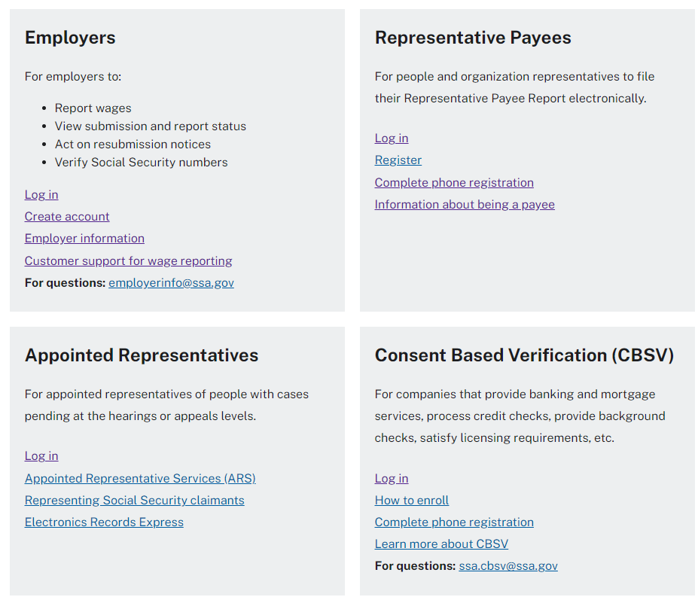

STEP 2: For AR, CBSV, or IRPA only select the Register or Log in link on the
Business Services Online Welcome page in the appropriate box. The system displays
the Log in to Online Services page.

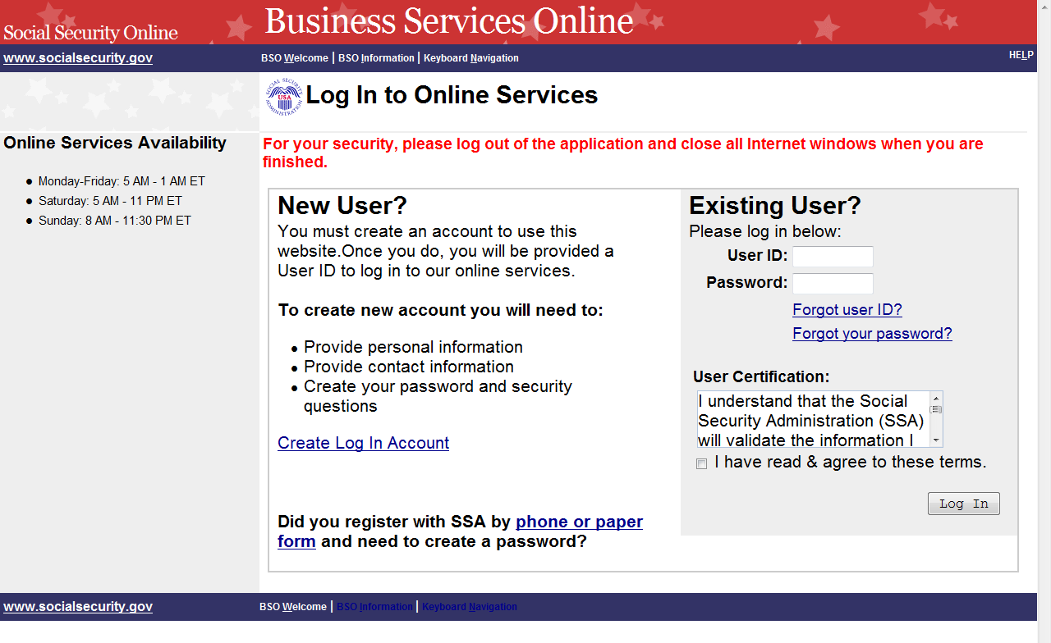

STEP 3: In the New User? column on the Log in to Online Services page, select the Create Log
In Account link. The system displays the Create a Login Account. Below is the User
Registration Attestation screen. Select I Accept to continue.

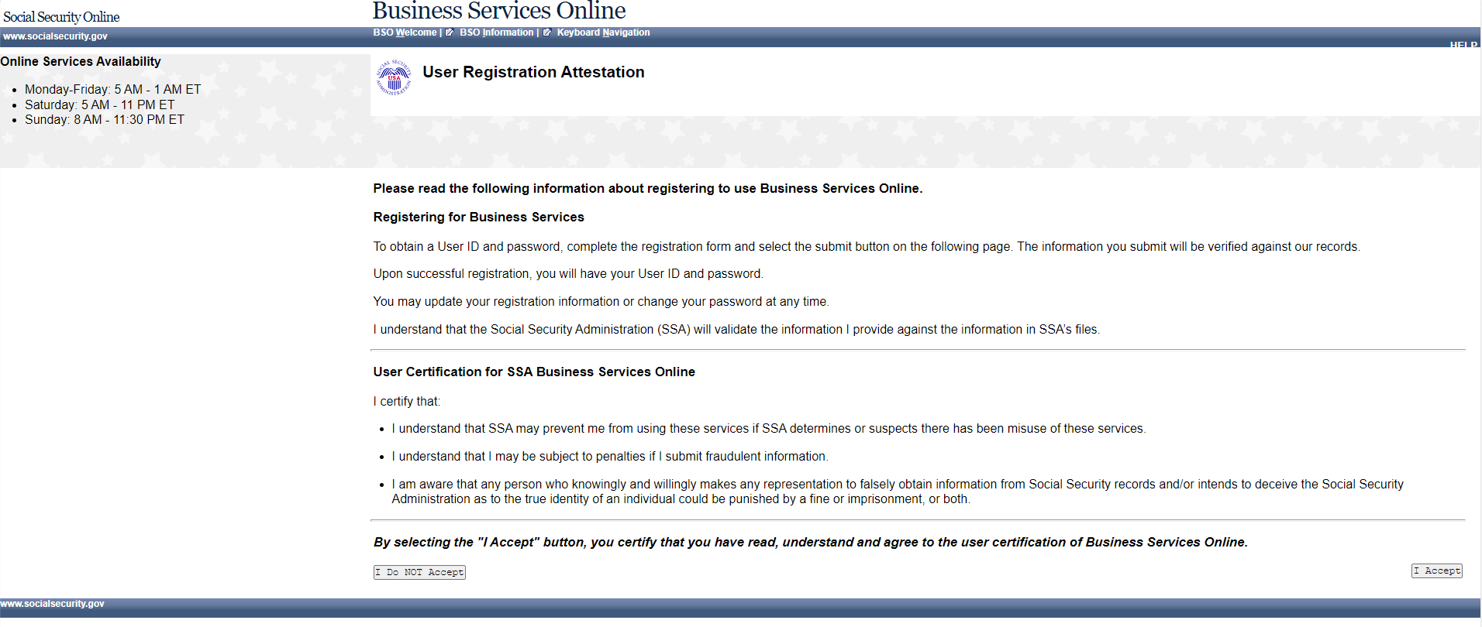

Step 1: Provide Information page. (To return to the Business Services Online Welcome page,
select the BSO Welcome link in the page footer.)

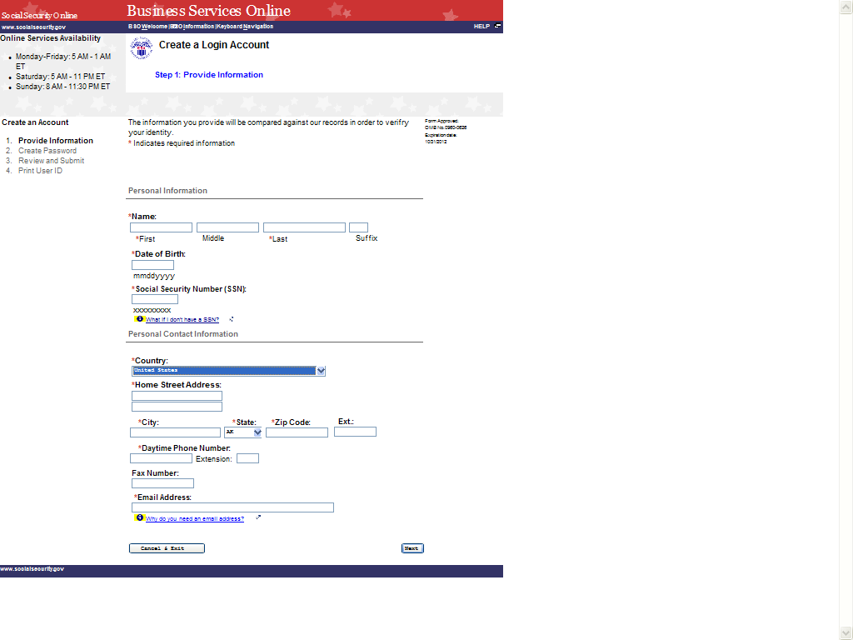

STEP 4: Enter information in the Create a Login Account, Step 1: Provide Information page.

TIPS
- Fields that are required are marked with a red asterisk (*).

- Links to informational pages are indicated with a blue information (i) link. Clicking on the link will display an informational page in a separate
window.

- Do not use punctuation in any field. This includes dashes or slashes in date
of birth, social security number, zip code, and phone or fax numbers.

- Date of birth must be entered in the format mmddyyyy. For example, if
your date of birth is January 1, 1990, you would enter 01011990.

- If you do not have an SSN and work outside the United States for a business
or organization that has an Employer Identification Number (EIN), you may
leave the SSN field blank.

- If you live outside of the United States, when you select your country, text
areas for you to enter Province and Postal Code information will appear.

- The Social Security Administration will use your email address to send you
any important information affecting Business Service Online users.

STEP 5: Select the Next button to continue registering. The system displays the Create a Login
Account, Step 2: Create Your Password page. (Select the Back button to return to
Create a Log in Account, Step 1: Provide Information. To return to the Business
Services Online Welcome page without registering, select the Cancel & Exit button.)

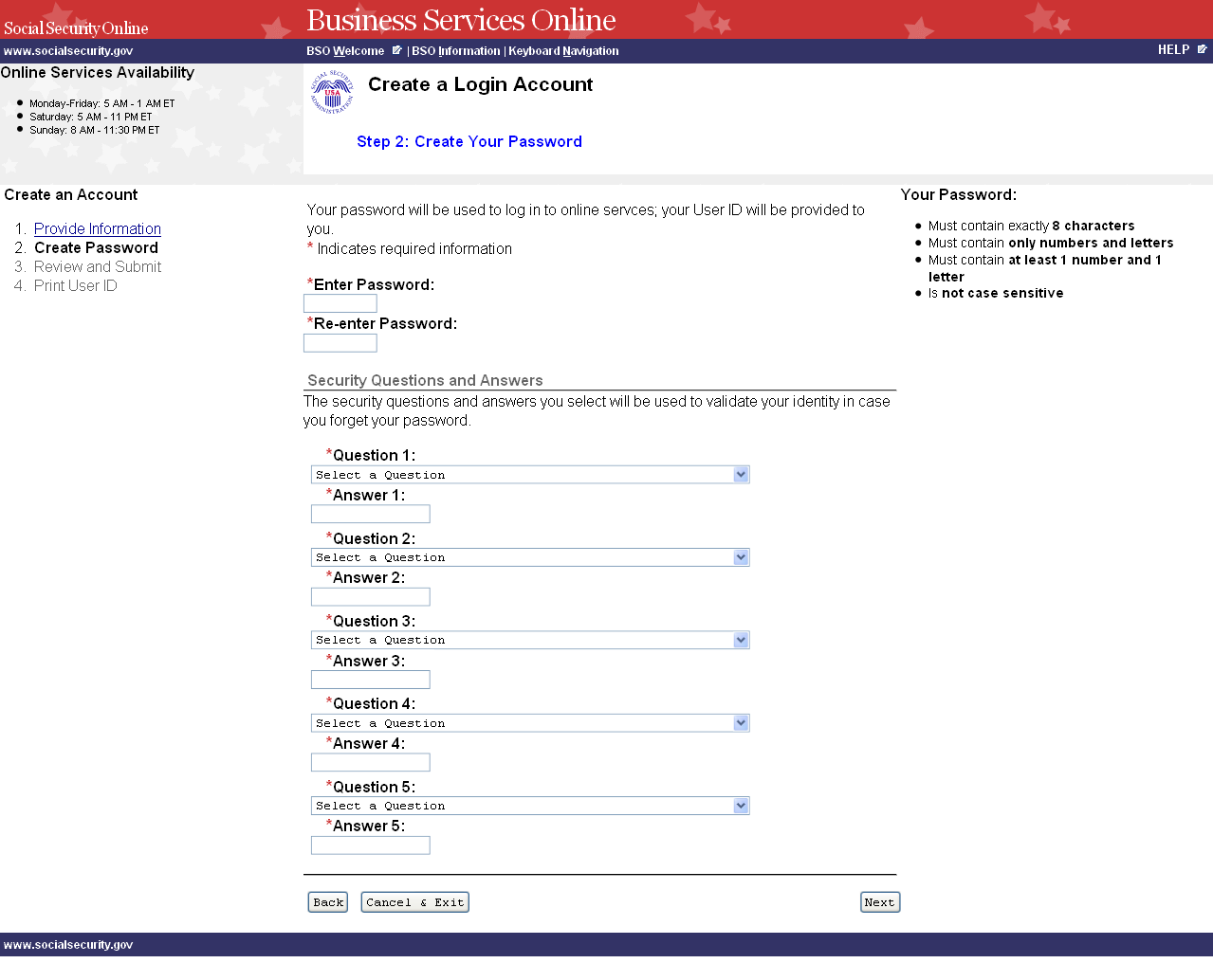

STEP 6: Enter a password to use when you log in to Business Services Online. Re-enter the
password for confirmation. Your password:

- Must contain exactly 8 characters.
- Must contain only numbers and letters (no special characters)
- Must contain at least 1 number and 1 letter.
- Is not case sensitive.

STEP 7: Select 5 questions and enter your answers. You will be asked to enter the same
answers if you need to change your password later.

- You may not select the same question more than once.
- Answers to questions are not case sensitive; they cannot contain any special
characters.

STEP 8: Select the Next button to continue. The system displays the Create a Login Account,
Step 3: Review and Submit page. (Select the Back button to return to the Create a Log
in Account, Step 1: Provide Information. To return to the Business Services Online
Welcome page without registering, select the Cancel & Exit button.)

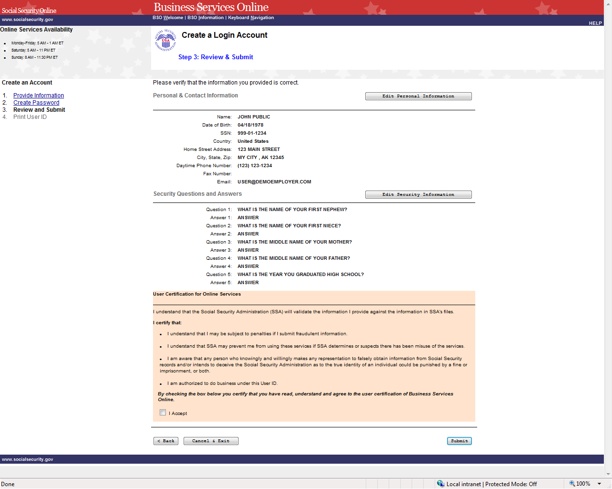

STEP 9: The information you entered on the previous two pages is displayed for your review. To make corrections, select the Edit Personal Information button to return to the

Create a Log in Account, Step 1: Provide Information page. Or select the Edit Security
Questions button or the Back button at the bottom of the page to return to the Create a
Login Account, Step 2: Create your Password page.

STEP 10: After making any corrections, read the conditions stated in the User Certification for
Online Services section of the page. You must agree to these conditions by checking
the I Accept checkbox to proceed. Select the Submit button to process the
registration. The system displays the Create a Login Account, Step 4: Print your User
ID. (Select the Back button at the bottom of the page to return to Create a Login
Account, Step 2: Create Your Password page. To return to the Business Services
Online Welcome page without registering, select the Cancel & Exit button.)

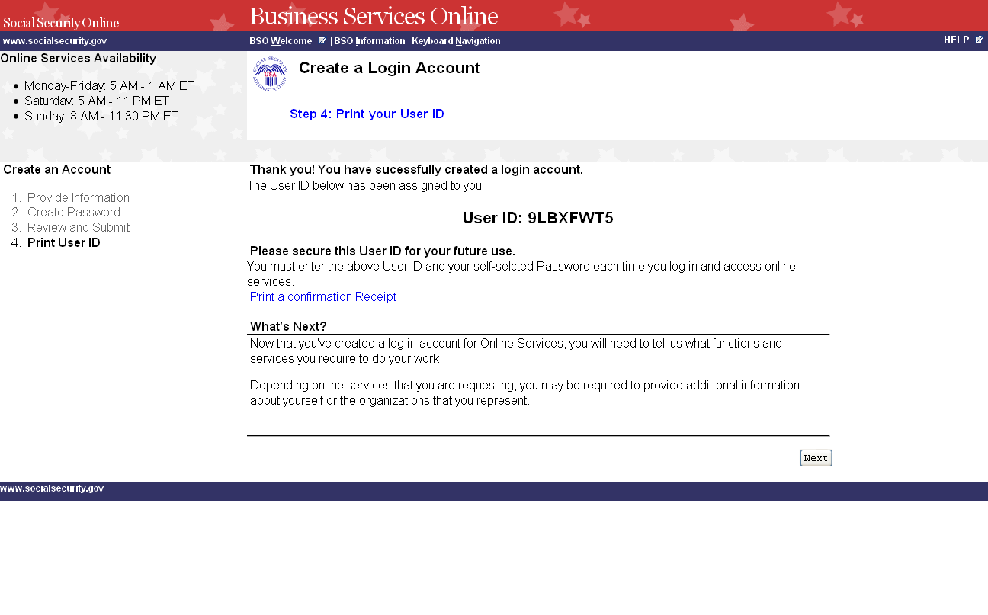

STEP 11: You may click on the Print a Confirmation Receipt link to print your User ID for
your records. You will need your User ID and password to log in to Business Services
Online to request services and perform other functions. Refer to other lessons in this Tutorial for guidance.

LESSON 2: COMPLETE PHONE REGISTRATION - For AR, CBSV

IRPA Only

If you started your registration for online services by speaking with an Employer Customer
Service representative or completing a form, follow the instructions below to complete your
registration.

STEP 1: Point your browser to the Business Services Online Welcome page: www.socialsecurity.gov/bso/bsowelcome.htm.

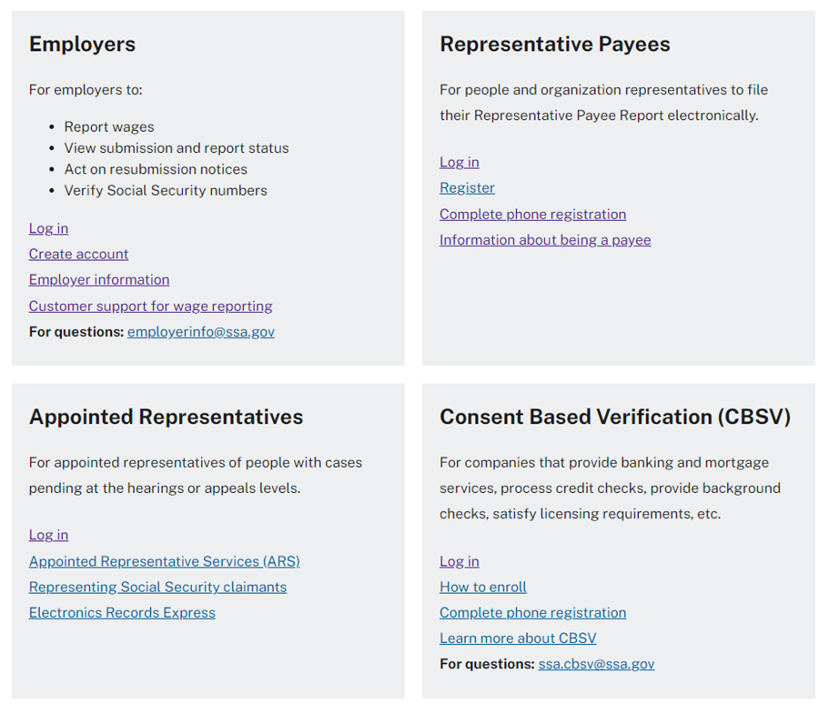

STEP 2: Select the Complete Phone Registration button on the Business Services Online Welcome page. The system displays the sign into Online Services page.

STEP 3: In the New User? column of the Log in to Online Services page, select the link portion
of Need to complete a phone/form registration? The system displays the Complete
Phone Registration Attestation page. (To return to the Business Services Online
Welcome page, select the BSO Welcome link in the page footer.)

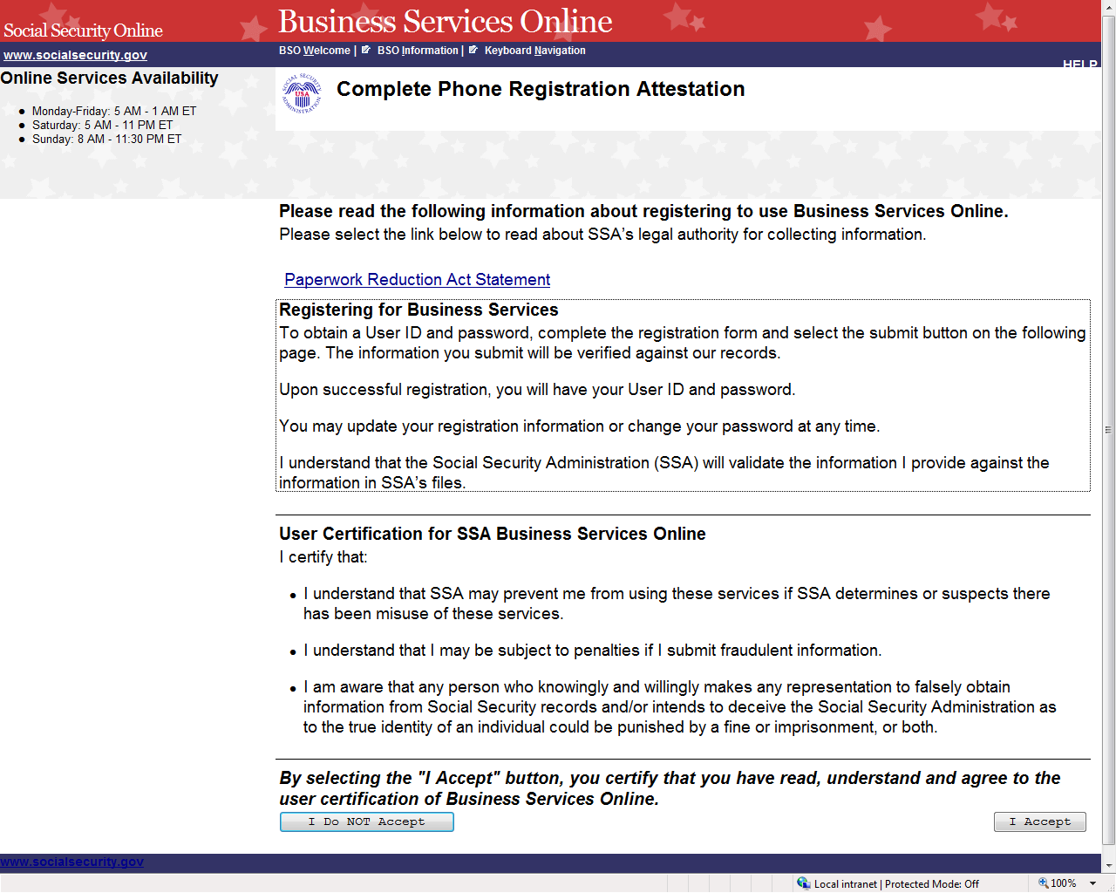

STEP 4: Read the conditions stated in the User Certification for SSA Business Services Online
section of the page. You must agree to these conditions by selecting the I Accept
button to proceed. The system displays the Complete Phone Registration page.
(Selecting the I Do NOT Accept button will display the Business Services Online
Welcome page.)

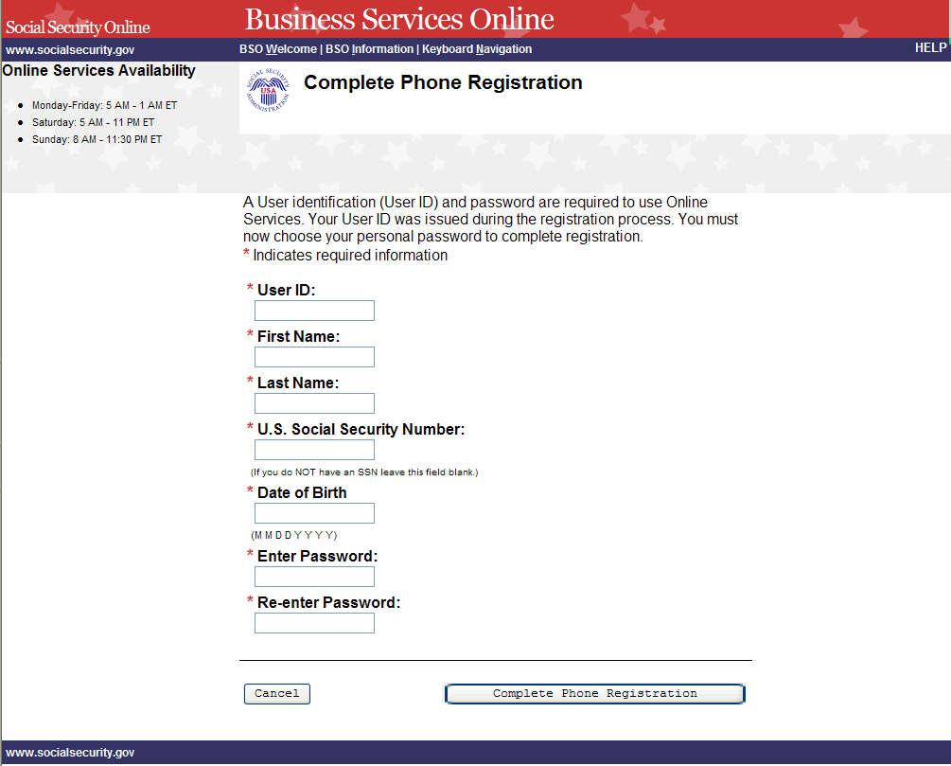

STEP 5: Enter the registration information.

TIPS
- Fields that are required are marked with a red asterisk (*).

- Enter your User ID that was given to you when you registered over the
phone or in person.

- Do not use punctuation in any field. This includes dashes or slashes in date
of birth and social security number.

- If you do not have a U. S. Social Security Number, leave the SSN field blank.

- Date of birth must be entered in the format mmddyyyy. For example, if your
date of birth is January 1, 1990, you would enter 01011990.

- Your password must contain any combination of eight letters and numbers
(e.g., 9580859A or frog2828). Special characters are not allowed, and
passwords are not case sensitive. Do not share your password with anyone.

- When you tab off or click out of a field, the system will check the format of
what was entered and display a message if it needs to be corrected.

STEP 6: Select the Complete Phone Registration button to complete the registration process.
The Log in to Online Services page will be displayed. (To return to the Business
Services Online Welcome page without completing the registration process, select the
Cancel button.)

LESSON 3: LOGIN - For AR, CBSV, and IRPA Only

Follow the instructions below to log in to Business Services Online with your User ID and
password.

STEP 1: Point your browser to the Business Services Online Welcome page: www.socialsecurity.gov/bso/bsowelcome.htm.

STEP 2: Select the Log In or Register link on the Business Services Online Welcome page.
The system displays the Log in to Online Services page.

STEP 3: Under the Existing User? column, enter your User ID and password. Read the terms
stated under the User Certification heading. You must agree to these conditions by
checking the “I have read & agree to these terms.” checkbox to proceed. Select the Log
In button. The system displays the Business Services Online Main Menu page.

- If you have forgotten your User ID, please call 1-800-772-6270 Monday through
Friday, 7:00 a.m. to 5:30 p.m. Eastern Time to speak with Employer Customer
Service personnel. For TDD/TTY, call 1-800-325-0778.

- If you have forgotten your password, select the Forgot your password? link beneath
the Password field. Refer to the Forgot Password lesson in this Tutorial for further
guidance.

(To return to the Business Services Online Welcome page, select the BSO Welcome
link on the page footer.)

NOTE

The menu selection on your BSO Main Menu is unique to you and presents only the
applications and services to which you have access.

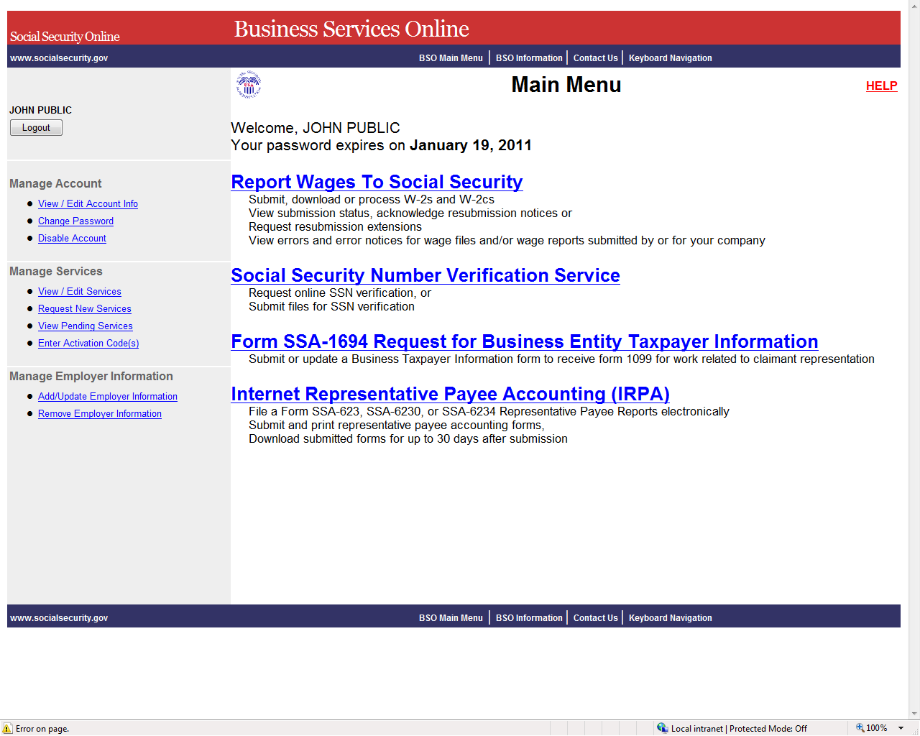

LESSON 4: FORGOT PASSWORD - For AR, CBSV, and IRPA Only

Follow the instructions below if you have forgotten your password and wish to get a new one.

STEP 1: Point your browser to the Business Services Online Welcome page: www.socialsecurity.gov/bso/bsowelcome.htm.

STEP 2: Select the Log In or Register button on the Business Services Online Welcome page.
The system displays the Log in to Online Services page.

STEP 3: Under the Existing User? column, enter your User ID. Select the Forgot your
password? link under the Password field. The system displays the Forgot Password
page. (To return to the Business Services Online Welcome page, select the BSO
Welcome link on the page footer.)
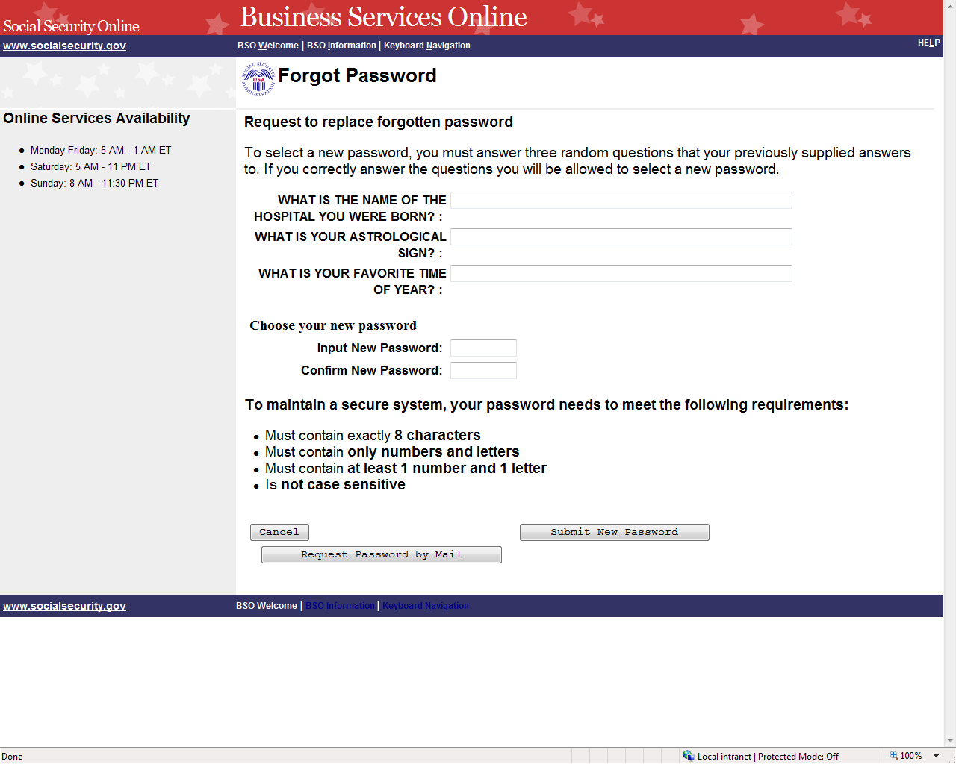

STEP 4: The Forgot Password page presents you with the choice of entering and submitting a
new password online or requesting a temporary password by mail.

- If you would like to change your password online immediately, continue to Step 5.

- If you would rather receive a temporary password by mail, you do not have to enter
anything on the Forgot Password page. Just select the Request Password by Mail
button and proceed to Step 7.

(To return to the Business Services Online Welcome page, select the Cancel button.)

STEP 5: Enter the answers to three security questions randomly selected from the five you
chose and answered during registration. Next, enter a new password and confirm that
password by entering it a second time. Select the Submit New Password button. The
system displays the Forgot Password Update Successful page. (To return to the
Business Services Online Welcome page without submitting the new password, select
the Cancel button.)

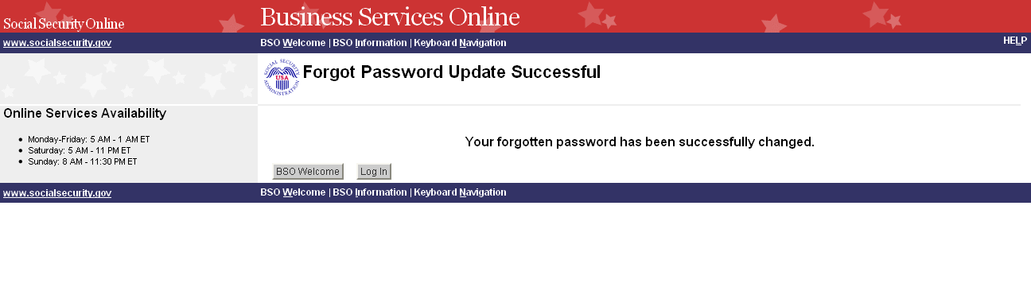
STEP 6: Select the Log In button to log in using the new password. Select the BSO Welcome
button to return to the Business Services Online Welcome page.

STEP 7: If you selected the Request Password by Mail button on the Forgot Password page,
the system displays the Request Password by Mail page.

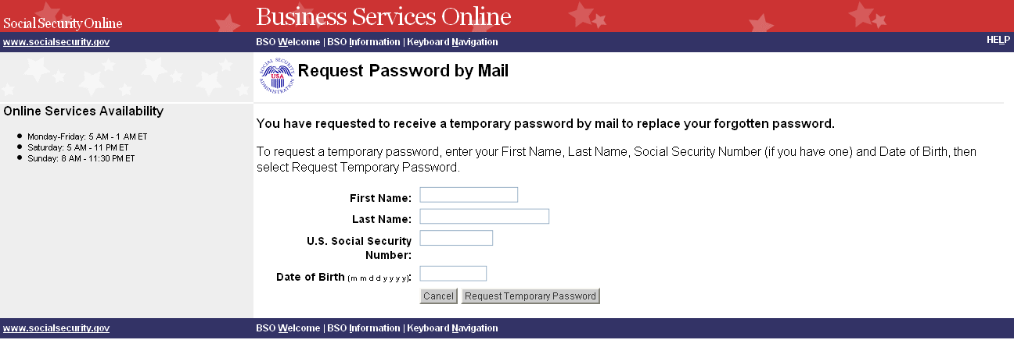

STEP 8: Enter your First Name, Last Name, U.S. Social Security Number, and Date of Birth.
Select the Request Temporary Password button to send the request. The system

displays the “Password By Mail Success” page. (To return to the Business Services
Online Welcome page without sending the request, select the Cancel button.)

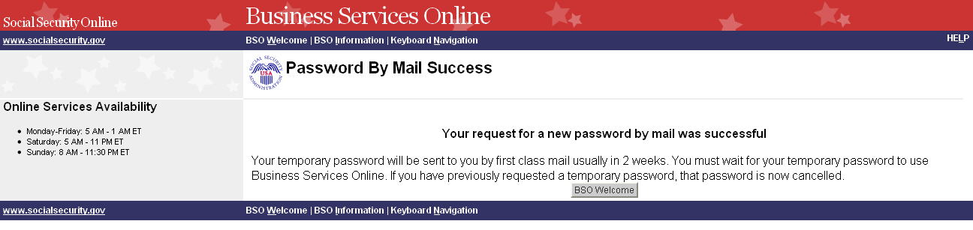

NOTE
Until you receive your new password in the mail, you will not be able to log in to BSO.

LESSON 5: LOGOUT

Follow the instructions below to log out of Business Services Online (BSO).

STEP 1: Select any Log Out button where displayed.

The system displays the Log Out of BSO page.

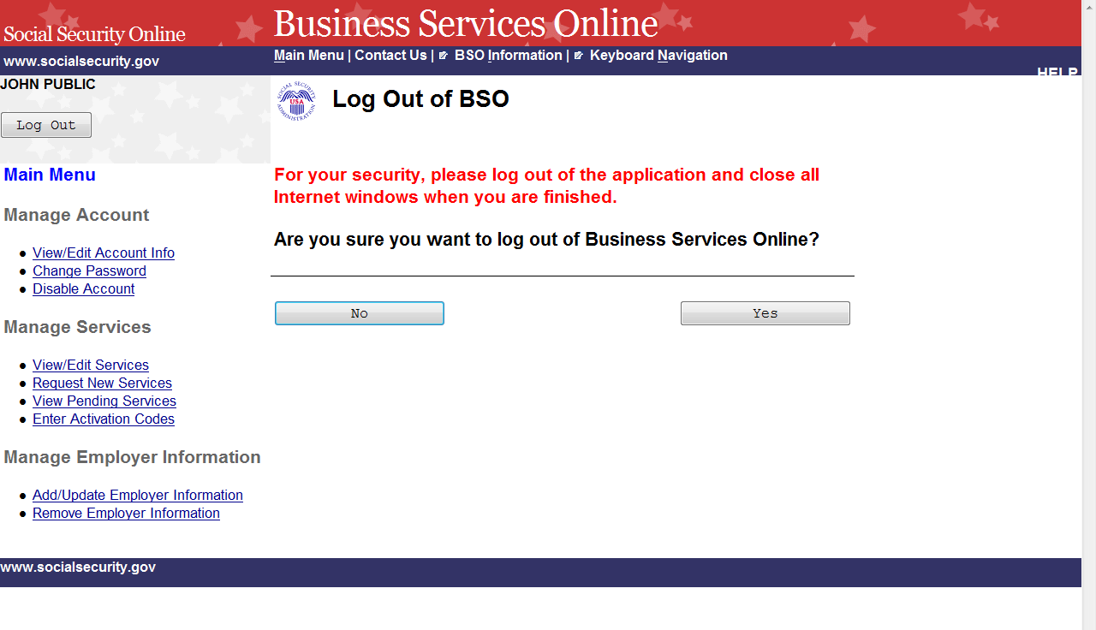

STEP 2: Select the Yes button to end the current session. The system displays the Customer
Satisfaction Survey or the Business Services Online Welcome page. (To continue your
session and return to the BSO Main Menu, select the No button.)

LESSON 6: CONTACT SOCIAL SECURITY ADMINISTRATION
(SSA)

Please visit https://www.ssa.gov/employer/empcontacts.htm to contact SSA.

LESSON 7: EDIT ACCOUNT INFORMATION

Follow the instructions below to update your account information.

STEP 1: Point your browser to the Business Services Online Welcome page: www.socialsecurity.gov/bso/bsowelcome.htm.

STEP 2: Select the Log In link on the Business Services Online Welcome page.

STEP 3: Under the Existing User? column, enter your User ID and password (AR, CBSV, and
IRPA only). Read the terms stated under the User Certification heading. You must agree to these
conditions by checking the “I have read & agree to these terms.” checkbox to proceed. Select the
Log In button. The system displays the Business Services Online Main Menu page. (To return to
the Business Services Online Welcome page, select the BSO Welcome link on the page footer.)

NOTE

The menu selection on your BSO Main Menu is unique to you and presents only the
applications and services to which you have access.

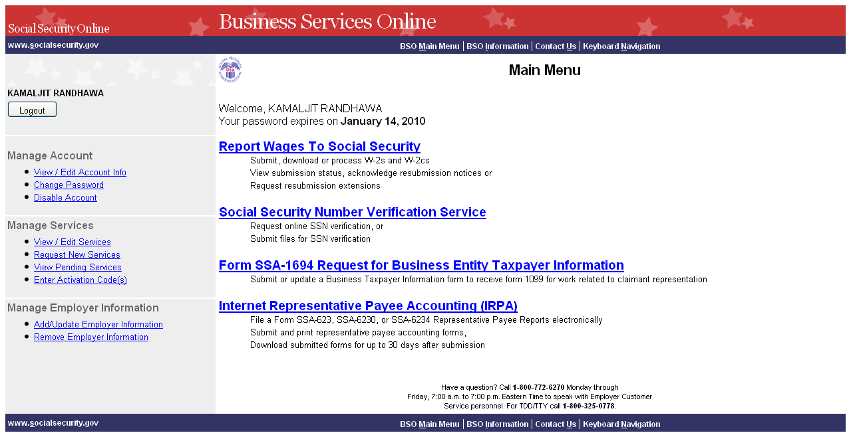

STEP 4: Under the Manage Account section of the left navigation panel, select the View/Edit
Account Info link. The system displays the View/Edit Account Information page. (To
return to the Business Services Online Main Menu, select the BSO Main Menu link in
the second line of the page header.)

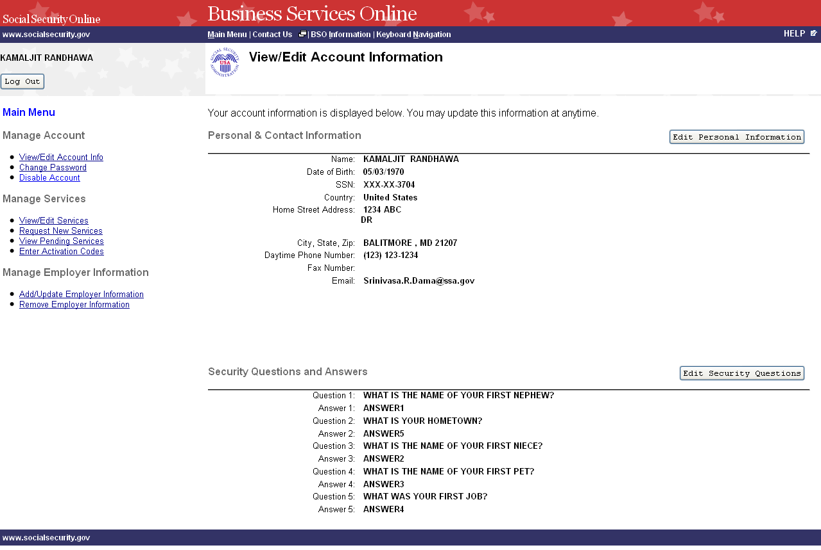

STEP 5: Select the Edit Personal Information button to edit personal and contact information.
The system displays the Edit Personal & Contact Information page. (To return to the
Business Services Online Main Menu, select the BSO Main Menu link in the second
line of the page header.)

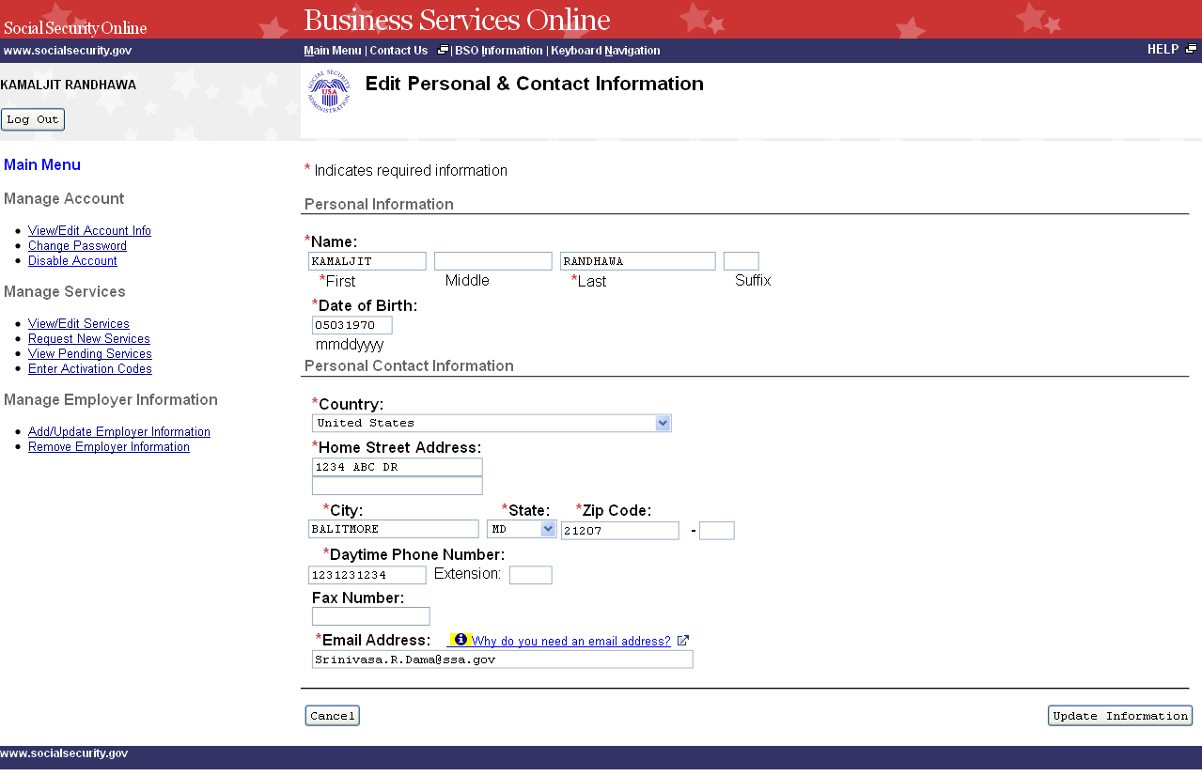

STEP 6: Edit the information you wish to change. Select the Update Information button to
update the account information. The system displays the Edit Personal & Contact
Information – Confirmation page. (Select the Cancel button to cancel the update and
return to the View/Edit Account Information page. To return to the Business Services
Online Main Menu, select the BSO Main Menu link in the second line of the page
header.)

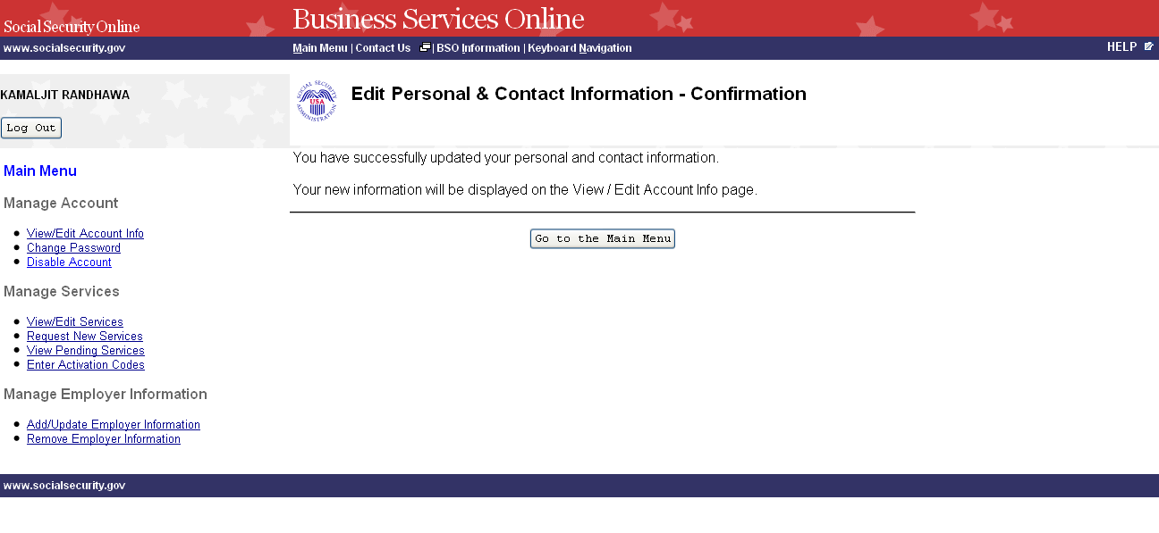
STEP 7: To edit other account information, select the View/Edit Account Info link under the
Manage Account section of the left navigation panel. The system displays the
View/Edit Account Information page. (Select the Go to the Main Menu button to
return to the Business Services Online Main Menu.)

STEP 8: Select the Edit Security Questions button to edit the five questions and answers used
to verify your identity if you forget your password. The system displays the Edit
Security Questions page. (To return to the Business Services Online Main Menu,
select the BSO Main Menu link in the second line of the page header.)

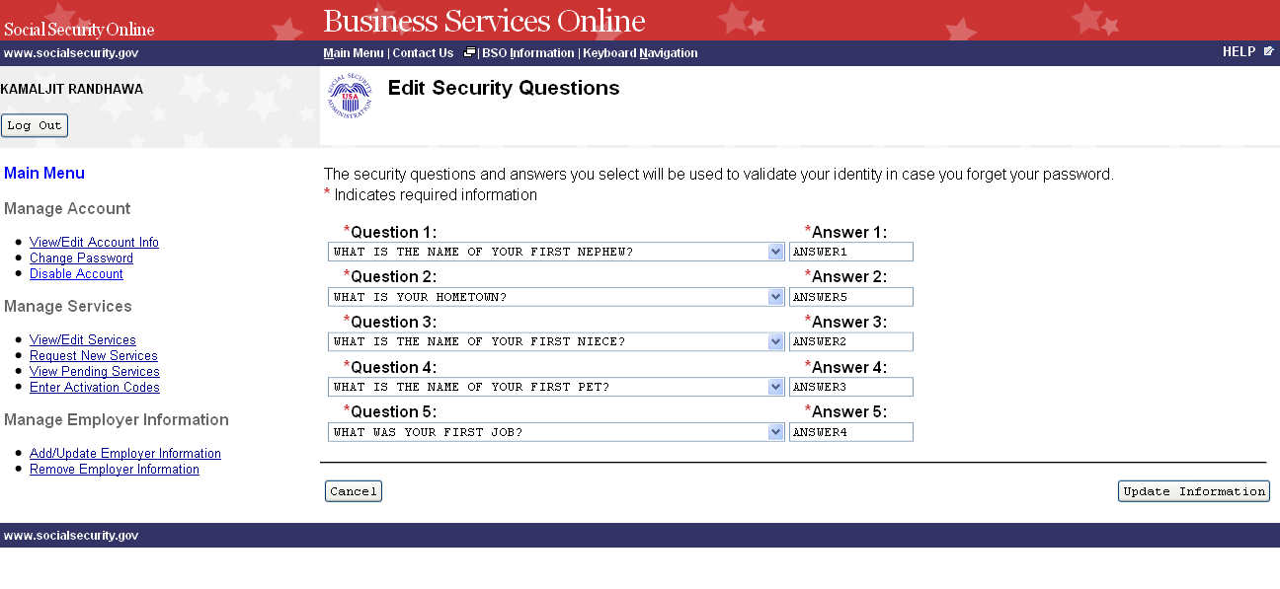
STEP 9: Edit the information you wish to change. Select the Update Information button to
update the account information. The system displays the Edit Security Questions –
Confirmation page. (Select the Cancel button to cancel the update and return to the
View/Edit Account Information page. To return to the Business Services Online Main
Menu, select the BSO Main Menu link in the second line of the page header.)

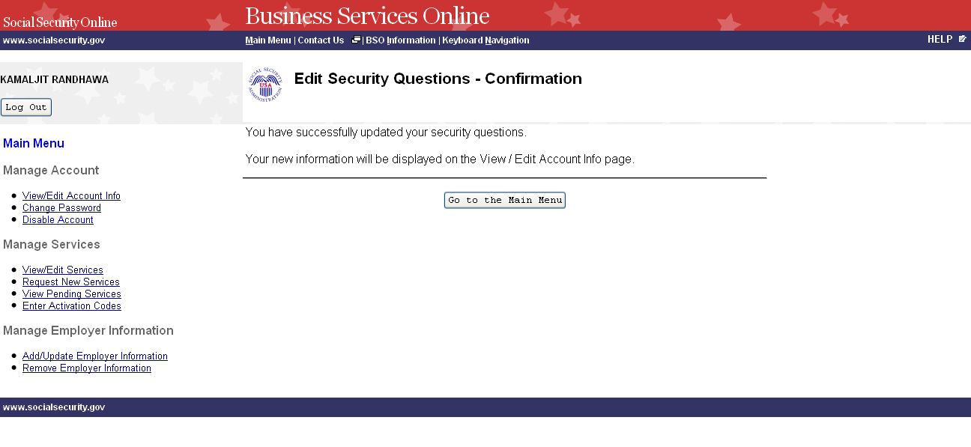
STEP 10: Select the Go to the Main Menu button to return to the Business Services Online
Main Menu.

LESSON 8: CHANGE YOUR PASSWORD – AR, CBSV, and IRPA
Only

You can change your password at any time. For security purposes, you are required to change
your password at least once every 90 days in order to maintain an active User Identification
Number (User ID). Follow the instructions below to change your password.

STEP 1: Point your browser to the Business Services Online Welcome page: www.socialsecurity.gov/bso/bsowelcome.htm.

STEP 2: Select the Log In link on the Business Services Online Welcome page.

NOTE
When your password is more than 90 days old, the following message will display at
the top of the page:
It has been more than 90 days since your password has been changed. You must
change your password to continue with Online services.

The system will then automatically display the Change Password page. (Go to Step 5.)

STEP 3: Under the Existing User? column, enter your User ID and password. Read the terms
stated under the User Certification heading. You must agree to these conditions by
checking the “I have read & agree to these terms.” checkbox to proceed. Select the Log
In button. The system displays the Business Services Online Main Menu page. (To
return to the Business Services Online Welcome page, select the BSO Welcome link in
the page footer.)

NOTE
The menu selection on your BSO Main Menu is unique to you and presents only the
applications and services to which you have access.

STEP 4: Select the Change Password link from the left navigation panel. The system displays
the Change Password page.

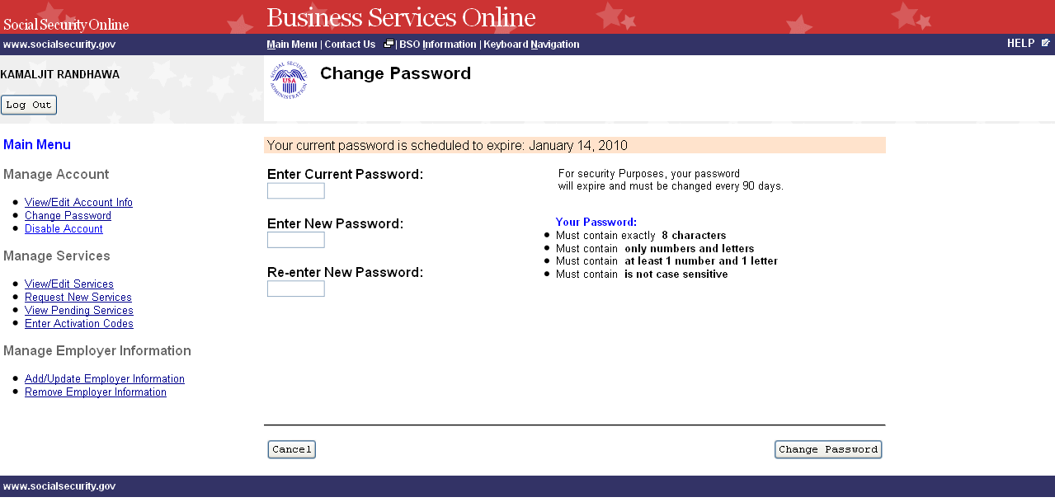

STEP 5: Enter your current password and new password. Enter your new password again for
verification purposes. Your new password:

- Must contain exactly 8 characters.
- Must contain only numbers and letters (no special characters)
- Must contain at least 1 number and 1 character.
- Is not case sensitive.

STEP 6: Select the Change Password button. The system displays the Password Change
Successful page. (To return to the Business Services Online Main Menu without
changing your password, select the Cancel button.)

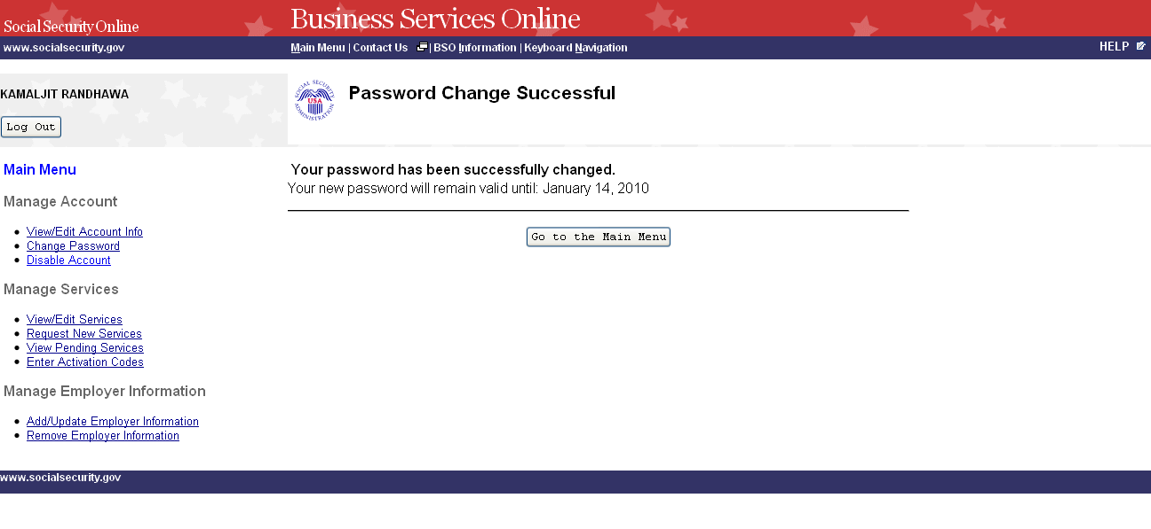
STEP 7: Select the Go to the Main Menu button to return to the Business Services Online
Main Menu.

LESSON 7: DISABLE YOUR ACCOUNT

Follow the instructions below to disable your account. When you disable your account, you will
no longer be able to use your User ID to access online services.

STEP 1: Point your browser to the Business Services Online Welcome page: www.socialsecurity.gov/bso/bsowelcome.htm.

STEP 2: Select the Log In link on the Business Services Online Welcome page.

STEP 3: Under the Existing User? column, enter your User ID and password (for AR, IRPA,
and CBSV only). Read the terms stated under the User Certification heading. You
must agree to these conditions by checking the “I have read & agree to these terms.”
checkbox to proceed. Select the Log In button. The system displays the Business
Services Online Main Menu page. (To return to the Business Services Online Welcome
page, select the BSO Welcome link on the page footer.)

NOTE

The menu selection on your BSO Main Menu is unique to you and presents only the applications and services to which you have access.

STEP 4: Under the Manage Account section of the left navigation panel, select the Disable
Account link. The system displays the Disable Account page.

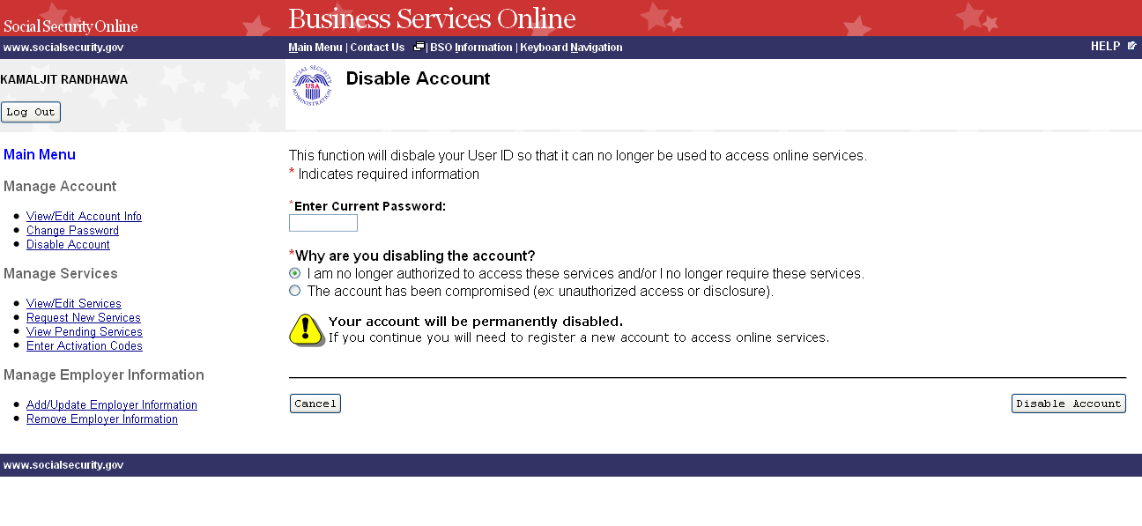
STEP 5: Enter your password in the Enter Current Password field and select the radio button
beside the reason for disabling your User ID. Select the Disable Account button. The
system displays the Disable Account – Confirmation page. (To return to the Business
Services Online Main Menu without disabling your user id, select the Cancel button.)

NOTE
If you select the Disable Account button, your account will be permanently disabled.
You will need to register a new account to access online services.
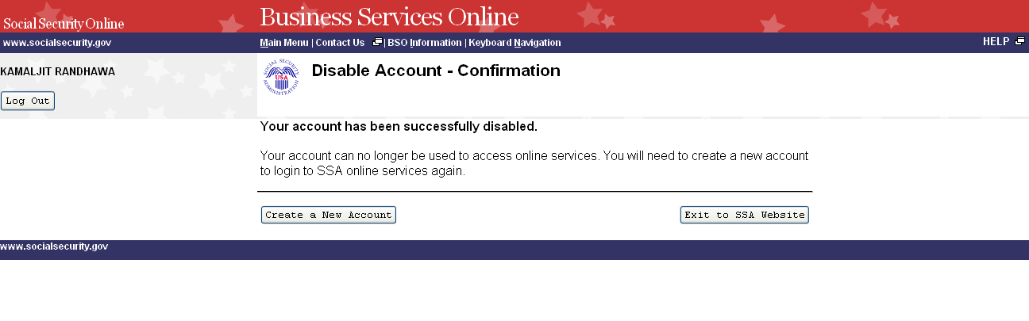
STEP 6: Select the Exit to SSA Website button to go to the Social Security Online page. To
register a new account to access online services, select the Create a New Account
button.

LESSON 8: REMOVE ACCESS TO BSO SERVICES

Follow the instructions below to remove access to one or more BSO services. Use this option if
you no longer need to use a service(s) in BSO.

STEP 1: Point your browser to the Business Services Online Welcome page: www.socialsecurity.gov/bso/bsowelcome.htm.

STEP 2: Select the Log In link on the Business Services Online Welcome page.

STEP 3: Under the Existing User? column, enter your User ID and password (for AR, CBSV,
and IRPA only). Read the terms stated under the User Certification heading. You must
agree to these conditions by checking the “I have read & agree to these terms.”
checkbox to proceed. Select the Log In button. The system displays the Business
Services Online Main Menu page. (To return to the Business Services Online Welcome
page, select the BSO Welcome link in the page footer.)

NOTE

The menu selection on your BSO Main Menu is unique to you and presents only the
applications and services to which you have access.

STEP 4: Under the Manage Services section of the left navigation panel, select the View/Edit
Services link. The system displays the Remove Access to BSO Services page. This
page lists the services to which you currently have access. (To return to the Business
Services Online Main Menu, select the BSO Main Menu link in the second line of the
page header.)

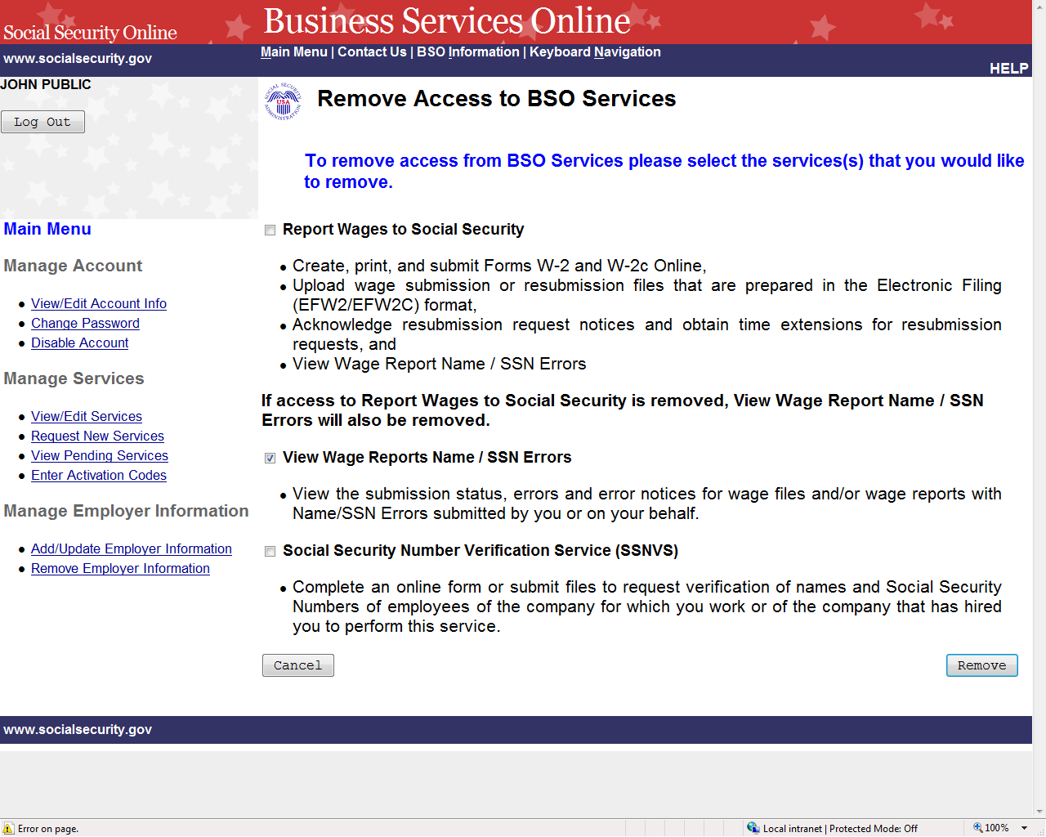

STEP 5: Select the checkbox(es) of the service(s) you wish to remove and select the Remove
button. The system displays the Remove Access to BSO Services Successful page.
(Select the Cancel button to return to the Business Services Online Main Menu without
removing any services. To return to the Business Services Online Main Menu, select
the BSO Main Menu link in the second line of the page header.)
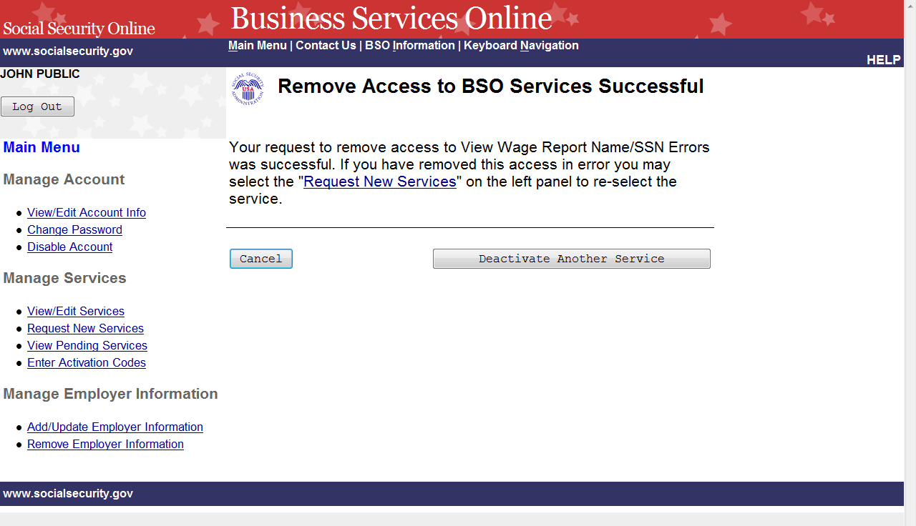

STEP 6: Select the Deactivate Another Service button to return to the Remove Access to BSO
Services page. Select the Cancel button to return to the Business Services Online Main
Menu.

LESSON 9: REQUEST SERVICES SUITE FOR EMPLOYERS

Follow the instructions below to log in to request access to the SSA Services Suite for Employers.
Note that the request for this suite can be combined with requests for other services. For guidance
in accessing a different service(s), refer to another lesson(s) in this Tutorial that specifically
addresses the service(s).

STEP 1: Point your browser to the Business Services Online Welcome page: www.socialsecurity.gov/bso/bsowelcome.htm.

STEP 2: Select “Log in” from the “Employers” box.

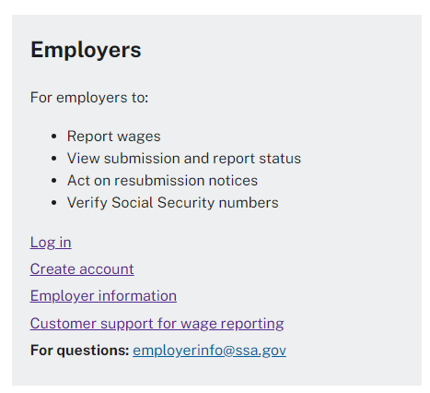

STEP 3: Select one of the options below to sign in.

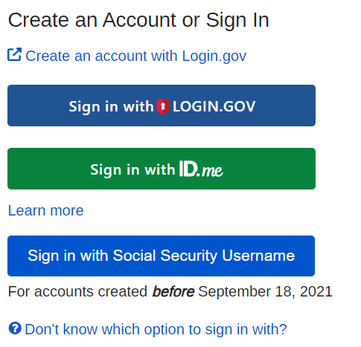

NOTE
The menu selection on your BSO Main Menu is unique to you and presents only the
applications and services to which you have access. Once the credentialing and
authentication process has been completed, current BSO User ID(s) will be associated
with your new credential.

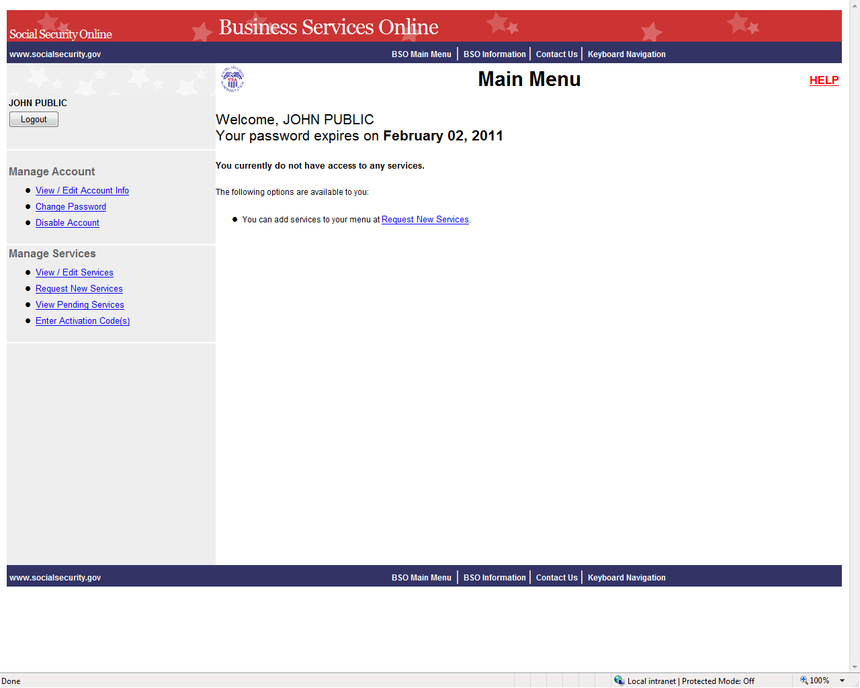

STEP 4: Select the Request New Services link in the Main Menu or the left navigation panel.
The system displays the Request Access to Services page. (To return to the Business
Services Online Welcome page, select the Logout button.)

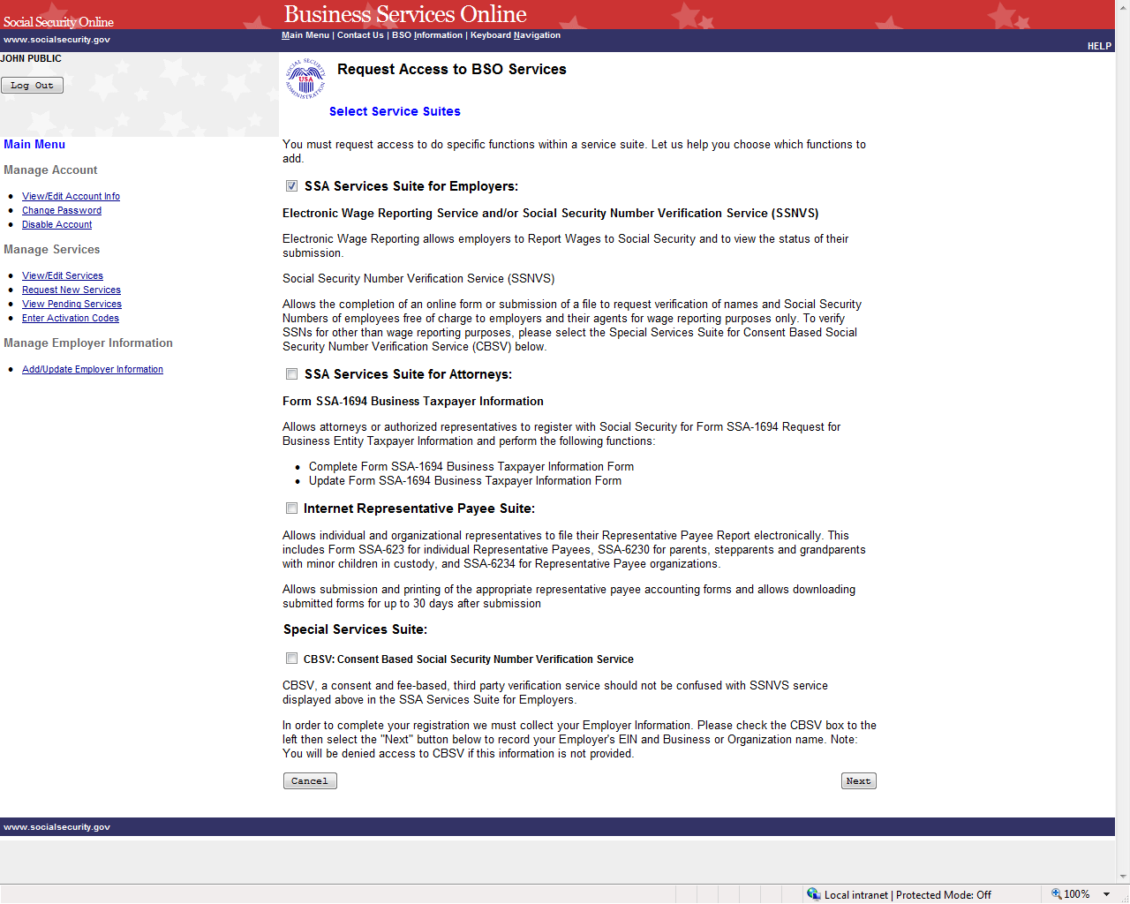

STEP 5: Continue with this lesson if you wish to request access to the Suite for Employers. If
a different or additional suite(s) of services is needed, refer to another lesson that
specifically addresses requesting that suite.

Check the checkbox saying “SSA Services Suite for Employers:” and select the Next
button.
- If Employer information has not been entered, the Request Access to BSO
Services page is re-displayed with the message “Employer Information is
required for the selected suite(s). Please select this link Add Your Employer
Information to continue.”
- If Employer information has already been entered, the system displays the
Adding Services Wizard pages for the suite(s) of services you selected.
(To return to the Business Services Online Main Menu page, select the Cancel
button.)

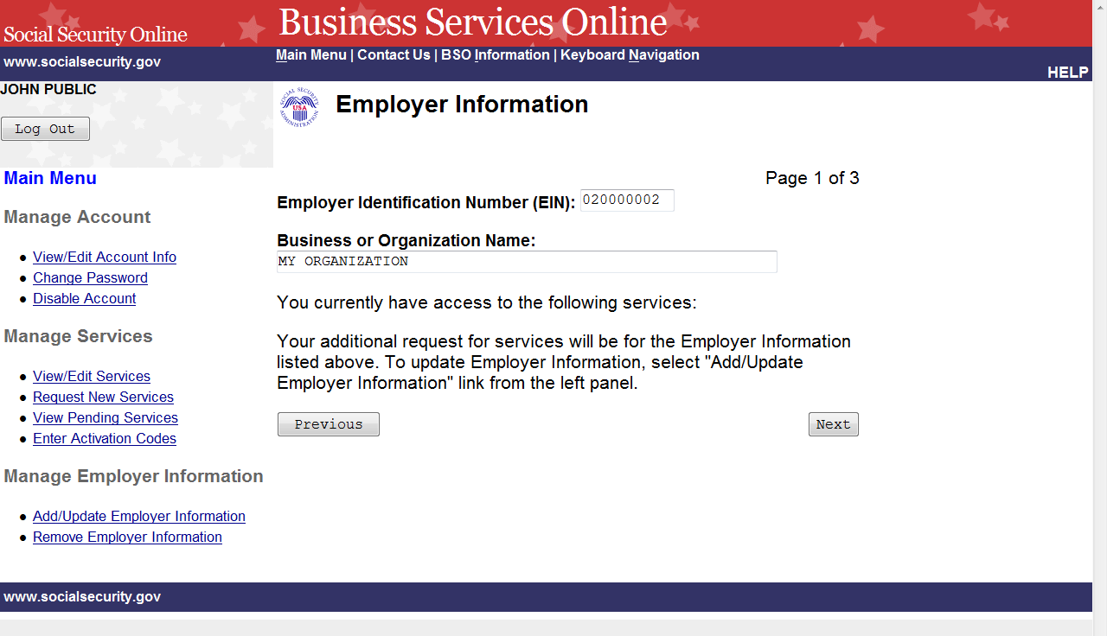

STEP 6: The Employer Identification Number (EIN) and Business or Organization name
associated to your User ID will be displayed. The services listed are only the ones to
which you have access. Select the Next button to continue. The system displays the
Report Wages to Social Security page of the adding services wizard. (Select the
Previous button at the bottom of the page to return to the Request Access to BSO
Services page. To return to the Business Services Online Main Menu, select Main
Menu on the second line of the page header.)

PLEASE NOTE: Access to the wage reporting service(s) involves a rigorous process and
requires pre-authorization from your employer. If access is requested, your employer will be
notified via first class mail, usually within 2 weeks. The notice will include an activation code
which is needed to activate your request.

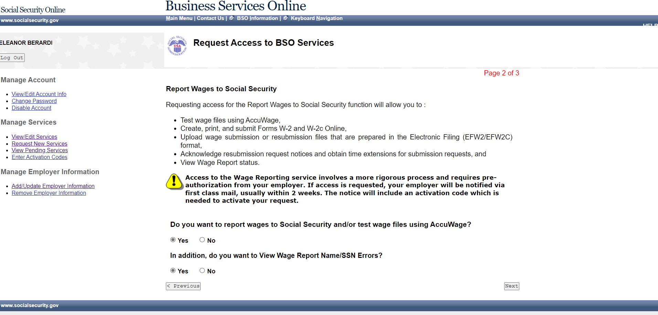

STEP 7: Request access to any service requires preauthorization from your employer. If access
is requested, your employer will be notified via first class mail, usually within 2 weeks. The
notice will include an activation code which is needed to activate your request.

If Report Wages is selected, the View Wage Report Name/SSN Errors may also be selected.
Select the Next button to continue.

The system displays the Social Security Number Verification Service (SSNVS) page of the
adding services wizard. (To return to the Employer Information page of the adding services
wizard, select the Previous button at the bottom of the page. To return to the Business Services
Online Main Menu without adding services, select Main Menu on the second line of the page
header.)

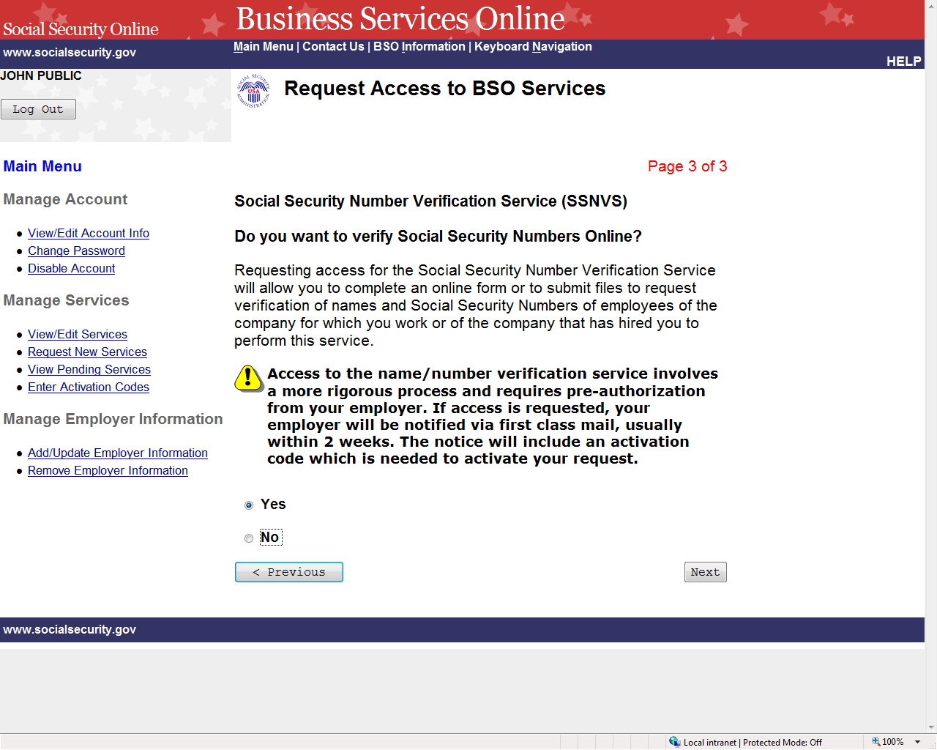

STEP 8: Request access to any service requires preauthorization from your employer. If access is
requested, your employer will be notified via first class mail, usually within 2 weeks. The notice
will include an activation code which is needed to activate your request.

Request access to Social Security Number Verification Service (SSNVS) by selecting the “Yes”
radio button and the Next button. The system displays the Request Summary page. (To return to
the Report Wages to Social Security page of the adding services wizard, select the Previous
button at the bottom of the page. To return to the Business Services Online Main Menu without
adding services, select Main Menu on the second line of the page header.)

NOTE
The functions listed on your Request Summary page is unique to you and presents only
the services which you have requested access.

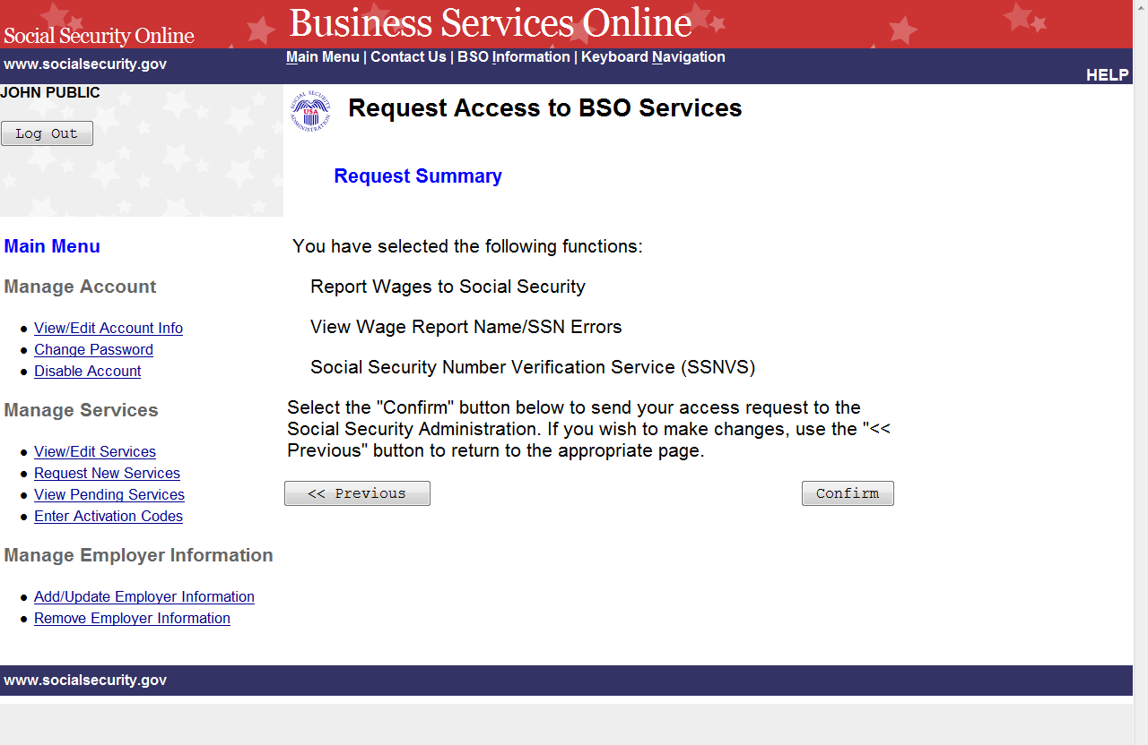

STEP 9: Review the list of functions and select the Confirm button to submit your access
request. The system will display the Request Access to BSO Services Confirmation
page. (To return to the Social Security Number Verification Service (SSNVS) page of
the adding services wizard, select the Previous button at the bottom of the page. To
return to the Business Services Online Main Menu without adding services, select
Main Menu on the second line of the page header.)

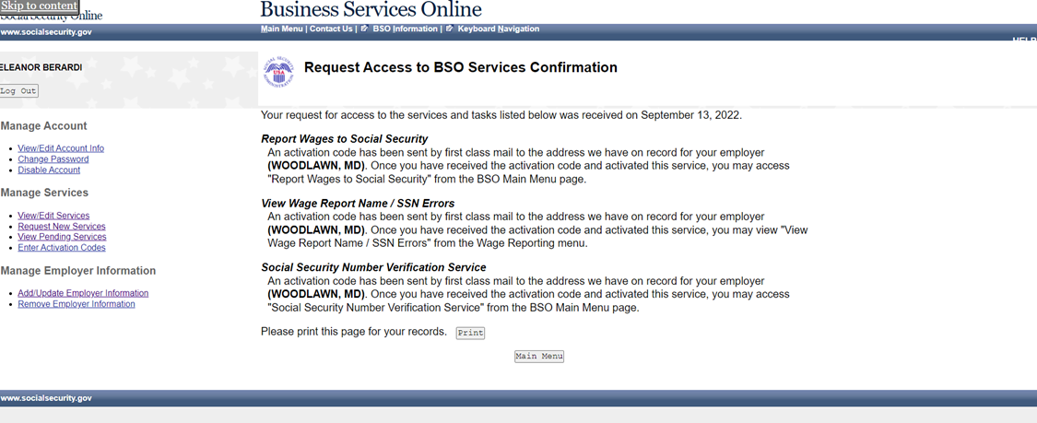

STEP 10: The confirmation page shows what services were selected. Please print this page for
your records. Activation codes will be mailed to the address we have on record for
your employer (please note the city and state shown) and are usually received within
two weeks. To return to the Business Services Online Main Menu, select the Main
Menu button.

NOTE
If the activation code(s) do not arrive at the address shown for your employer within
two weeks, you may re-request them. Refer to the Re-Request Activation Codes
lesson in this Tutorial for guidance.

LESSON 10: REQUEST SERVICES SUITE FOR ATTORNEYS

Follow the instructions below to request access to the SSA Services Suite for Attorneys. Note that
the request to this suite can be combined with requests to other services. For guidance in
accessing a different suite(s), refer to another lesson(s) in this Tutorial that specifically addresses
the service(s).

STEP 1: Point your browser to the Business Services Online Welcome page: www.socialsecurity.gov/bso/bsowelcome.htm.

STEP 2: Select the Login link on the Business Services Online Welcome page. The system
displays the Log in to Online Services page.

STEP 3: Under the Existing User? column, enter your User ID and password (for AR, CBSV,
or IRPA only). Read the terms stated under the User Certification heading. You must
agree to these conditions by checking the “I have read & agree to these terms.”
checkbox to proceed. Select the Log In button. The system displays the Business
Services Online Main Menu page. (To return to the Business Services Online Welcome
page, select the BSO Welcome link in the page footer.)

NOTE
The menu selection on your BSO Main Menu is unique to you and presents only the
applications and services to which you have access.

STEP 4: Under the Manage Services section in the left navigation panel, select the Request
New Services link. The system displays the Request Access to BSO Services page. (To
return to the Business Services Online Welcome page, select the Logout button.)

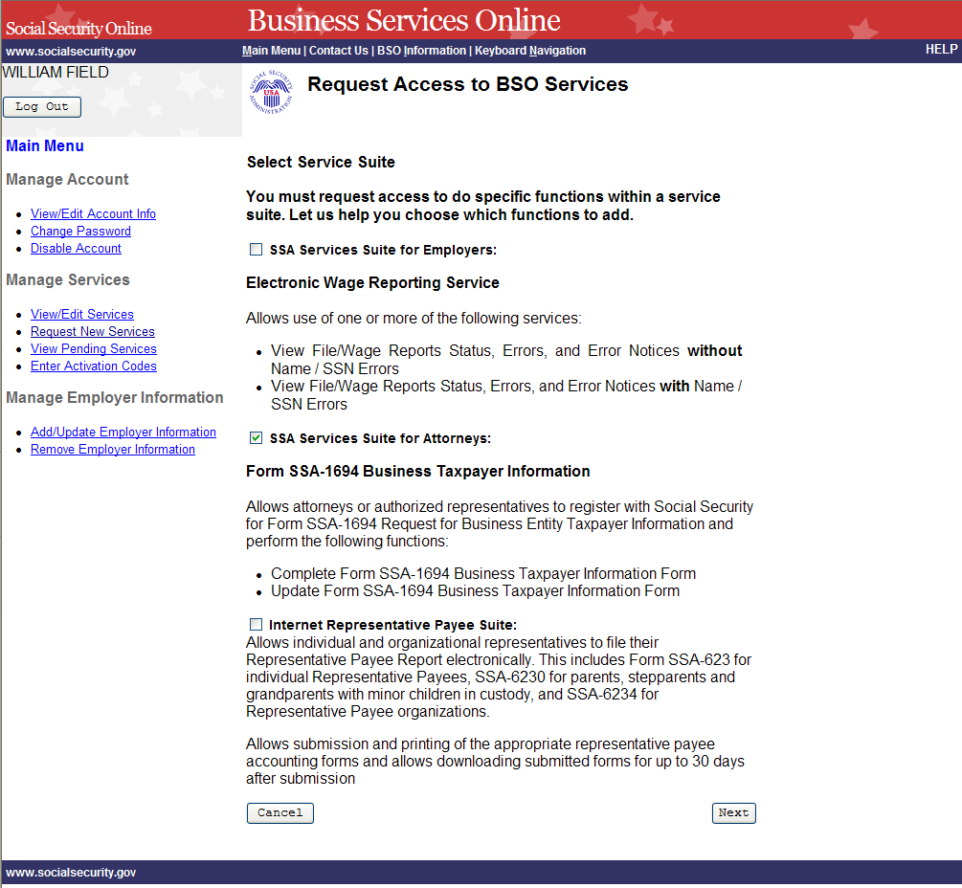

STEP 5: Continue with this lesson if you wish to request access to the SSA Services Suite for
Attorneys. If a different or additional suite(s) of services is needed, refer to another
lesson that specifically addresses requesting that suite.

Check the checkbox saying “SSA Services Suite for Attorneys:” and select the Next
button.
- If Employer information has not been entered, the Request Access to BSO
Services page is re-displayed with the message “Employer Information is
required for the selected suite(s). Please select this link Add Your Employer
Information to continue.”
- If Employer information has already been entered, the system displays the
Adding Services Wizard pages for the suite(s) of services you selected.
(To return to the Business Services Online Main Menu page, select the Cancel
button.)

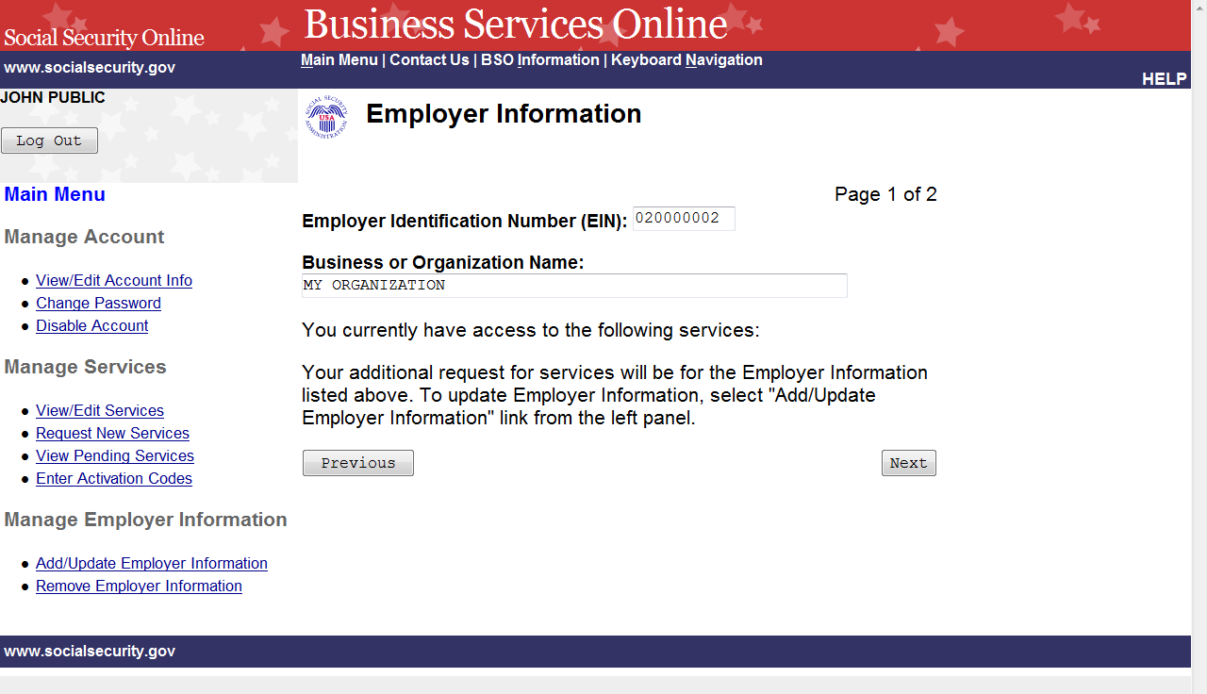

STEP 6: Review the employer information displayed.
- If the employer information displayed is incorrect, you may update your
employer information by selecting the Add/Update Employer Information link
on the left navigation panel.
- If the employer information displayed is correct, select the Next button. The
system displays the Complete Form SSA-1694 Business Taxpayer Information
Form page of the adding services wizard.

(Select the Previous button at the bottom of the page to return to the Request Access
to BSO Services page. To return to the Business Services Online Main Menu, select
Main Menu on the second line of the page header.)

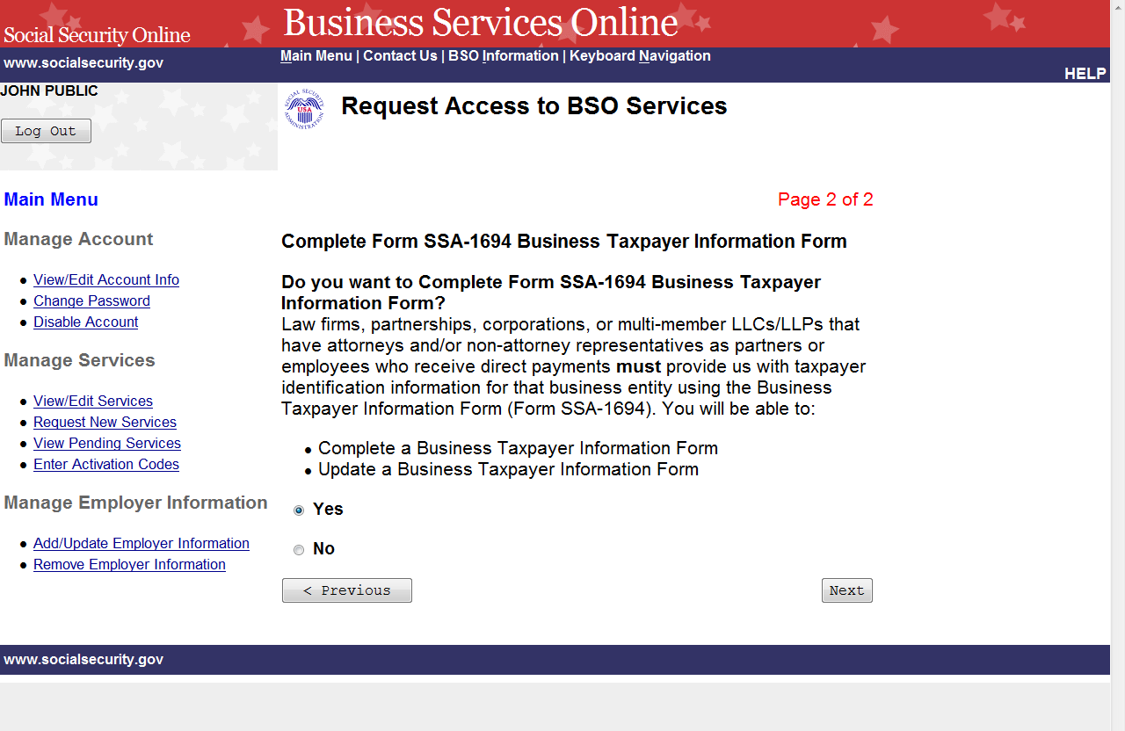

STEP 7: Request access to Complete Form SSA-1694 Business Taxpayer Information Form by
selecting the “Yes” radio button and the Next button. The system displays the Request
Summary page. (To return to the Employer Information page of the adding services
wizard, select the Previous button at the bottom of the page. To return to the Business
Services Online Main Menu without adding services, select Main Menu on the second
line of the page header.)

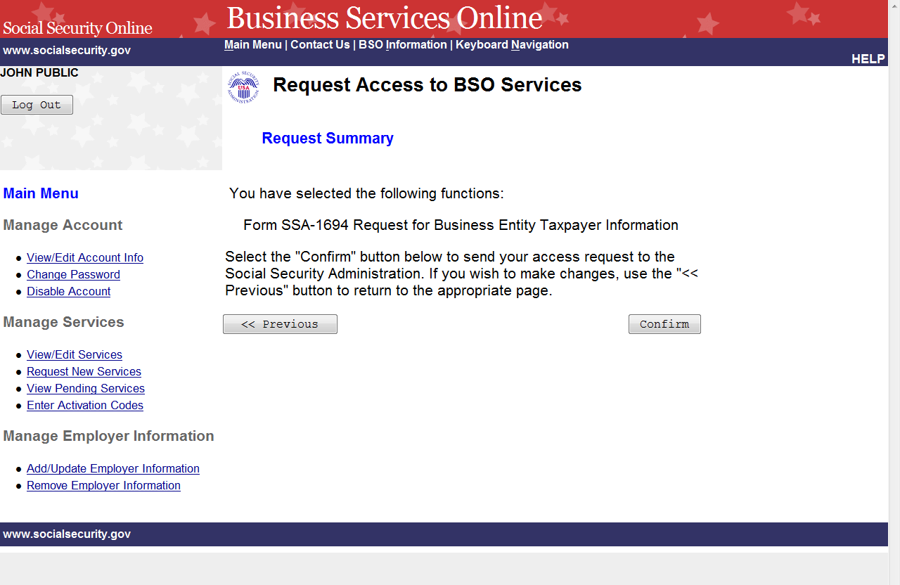

STEP 8: Review the list of services and select the Confirm button to submit your access
request. The system will display the Request Access to BSO Services Confirmation
page. (To return to the Complete Form SSA-1694 Business Taxpayer Information
Form page of the adding services wizard, select the Previous button at the bottom of
the page. To return to the Business Services Online Main Menu without adding
services, select Main Menu on the second line of the page header.)

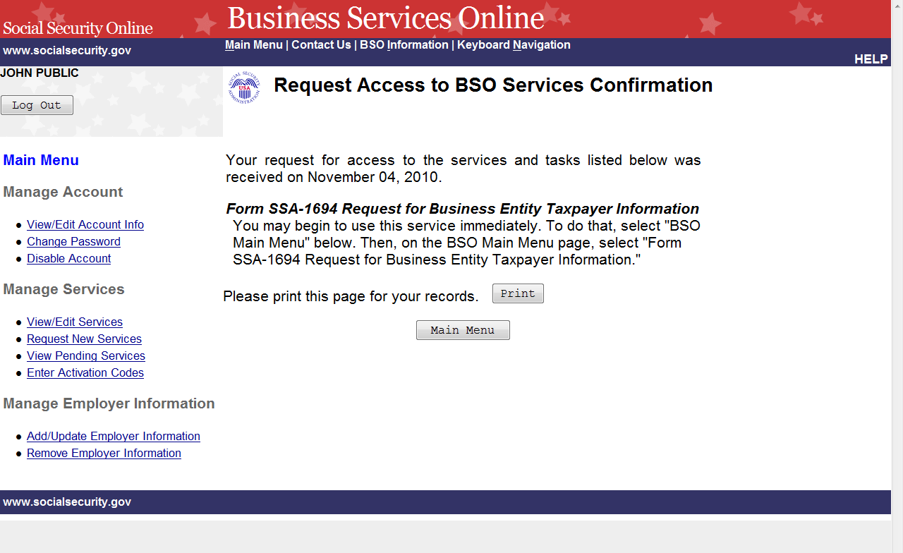
STEP 9: The confirmation screen shows the selected service. A print button may be selected to
print the confirmation. To return to the Main Menu, select the Main Menu button.

LESSON 11: REQUEST INTERNET REPRESENTATIVE PAYEE
SUITE

Follow the instructions below to request services in the Internet Representative Payee Suite. Note
that the request to this suite can be combined with requests to other services. For guidance in
accessing a different suite(s), refer to another lesson(s) in this Tutorial that specifically addresses
that service(s).

STEP 1: Point your browser to the Business Services Online Welcome page: www.socialsecurity.gov/bso/bsowelcome.htm.

STEP 2: Select the Login link on the Business Services Online Welcome page. The system
displays the Log in to Online Services page.

STEP 3: Under the Existing User? column, enter your User ID and password. Read the terms
stated under the User Certification heading. You must agree to these conditions by
checking the “I have read & agree to these terms.” checkbox to proceed. Select the Log
In button. The system displays the Business Services Online Main Menu page. (To
return to the Business Services Online Welcome page, select the BSO Welcome link on
the page footer.)

NOTE
The menu selection on your BSO Main Menu is unique to you and presents only the
applications and services to which you have access.

STEP 4: Under the Manage Services section in the left navigation panel, select the Request
New Services link. The system displays the Request Access to BSO Services page. (To
return to the Business Services Online Welcome page, select the Logout button.)

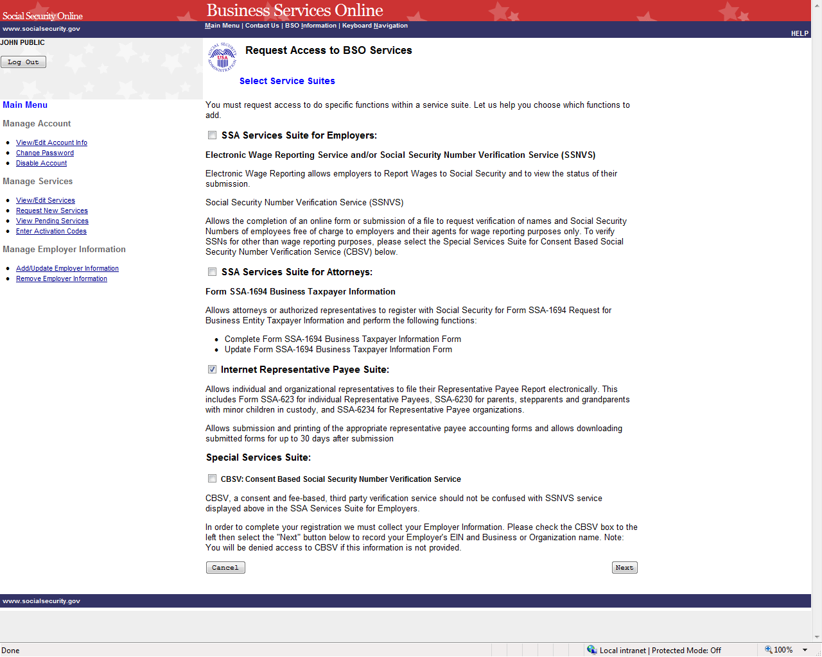

STEP 5: Continue with this lesson if you wish to request access to the Internet Representative
Payee Suite. If a different or additional suite(s) of services is needed, refer to another
lesson that specifically addresses requesting that suite.

Check the checkbox saying, “Internet Representative Payee Suite:” and select the Next
button. The system displays the Internet Representative Payee page of the adding
services wizard. (To return to the Business Services Online Main Menu page, select the
Cancel button.)

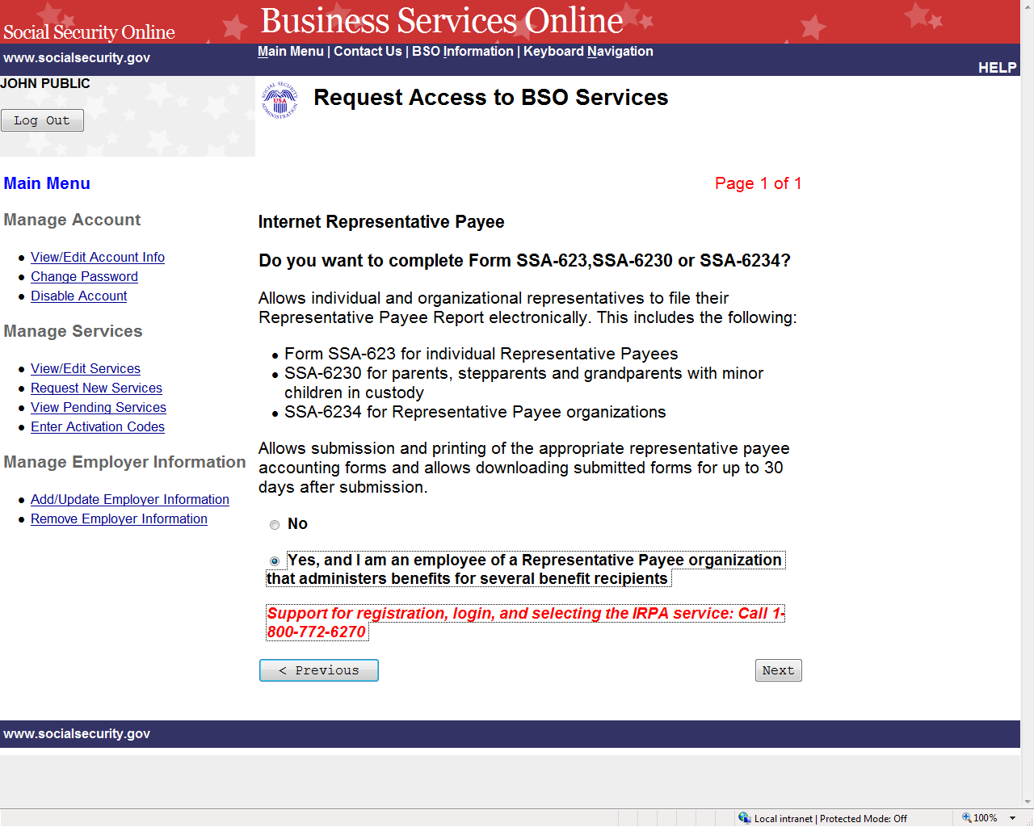

STEP 6: Request access to complete the forms to file the Representative Payee Report
electronically by selecting the “Yes” radio button and the Next button. The system
displays the Request Summary page. (To return to the Select Access to BSO Services
page, select the Previous button at the bottom of the page. To return to the Business
Services Online Main Menu without adding services, select Main Menu on the second
line of the page header.)

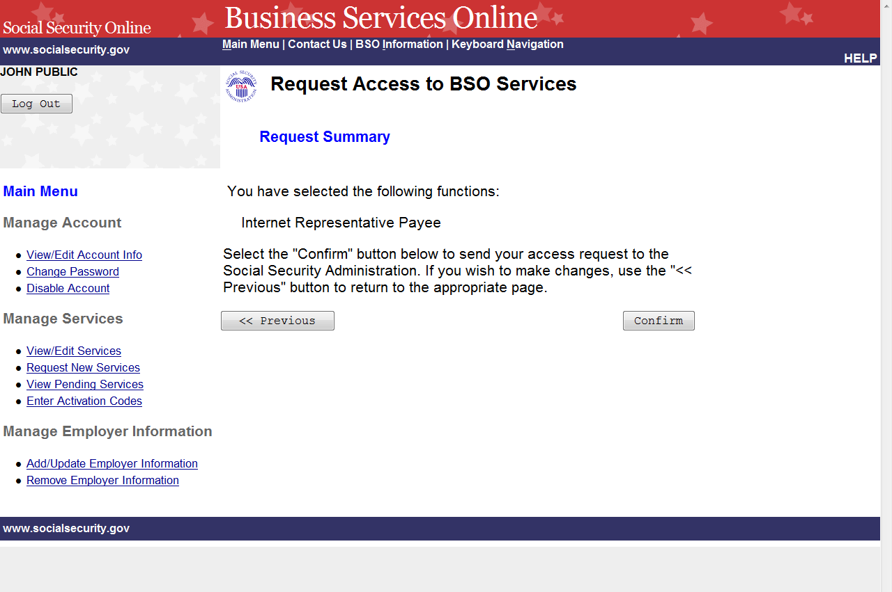

STEP 7: Select the Confirm button to submit your access request. The system will display the
Request Access to BSO Services Confirmation page. (To return to the Internet
Representative Payee page of the adding services wizard, select the Previous button at
the bottom of the page. To return to the Business Services Online Main Menu without
adding services, select Main Menu on the second line of the page header.)

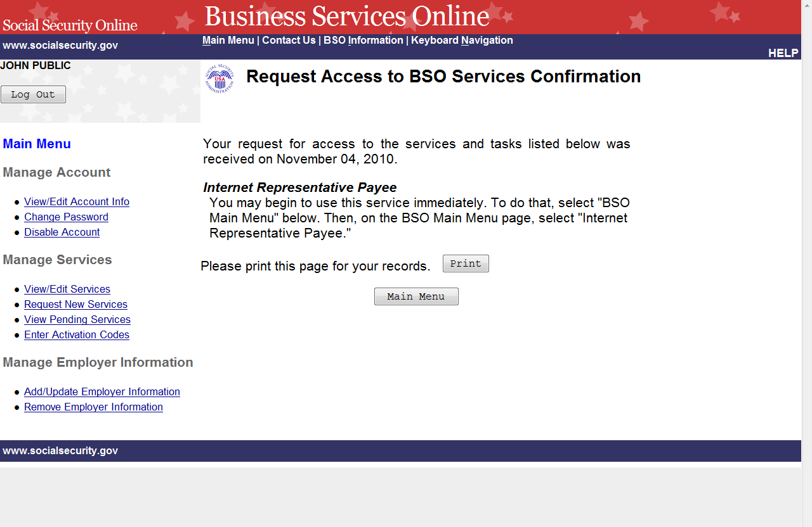
STEP 8: The confirmation screen informs you that you may begin to use this service
immediately. To return to the Main Menu, select the Main Menu button.

LESSON 12: RE-REQUEST ACTIVATION CODES

Follow the instructions below to re-request activation codes for BSO services. Use this option if
you have not received your activation codes from Social Security or if you have misplaced them.
You may re-request activation codes if it has been at least 10 days since you requested access to
BSO services. If you re-request any activation codes, previously issued codes will no longer be
valid.

STEP 1: Point your browser to the Business Services Online Welcome page: www.socialsecurity.gov/bso/bsowelcome.htm.

STEP 2: Select the Log In link on the Business Services Online Welcome page. The system
displays the Log in to Online Services page.

STEP 3: Under the Existing User? column, enter your User ID and password. Read the terms
stated under the User Certification heading. You must agree to these conditions by
checking the “I have read & agree to these terms.” checkbox to proceed. Select the Log
In button. The system displays the Business Services Online Main Menu page. (To
return to the Business Services Online Welcome page, select the BSO Welcome link in
the page footer.)

NOTE

The menu selection on your BSO Main Menu is unique to you and presents only the
applications and services to which you have access.

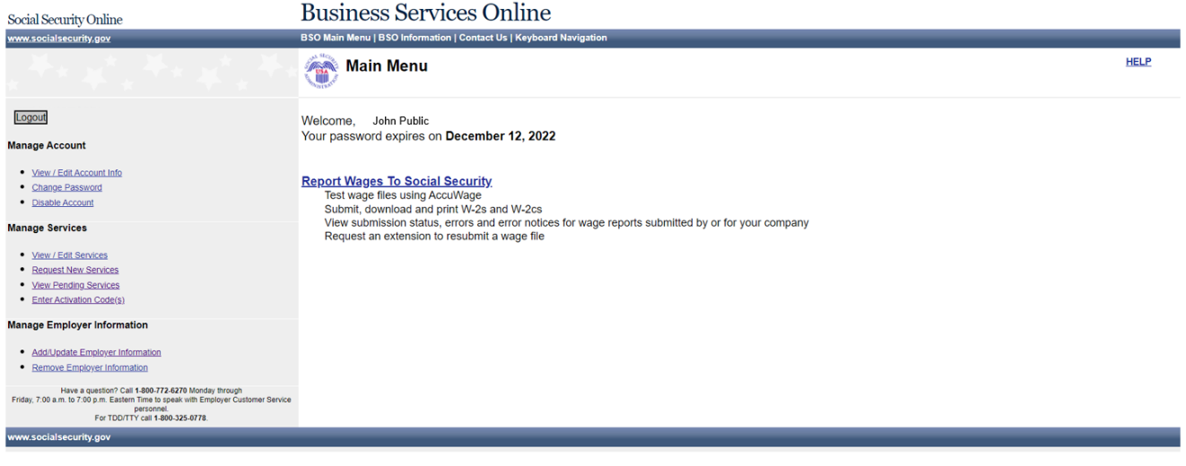

STEP 4: Under the Manage Services section of the left navigation panel, select the View
Pending Services link. The system displays the Re-Request Activation Codes page.
This page lists the services for which you are awaiting activation codes.

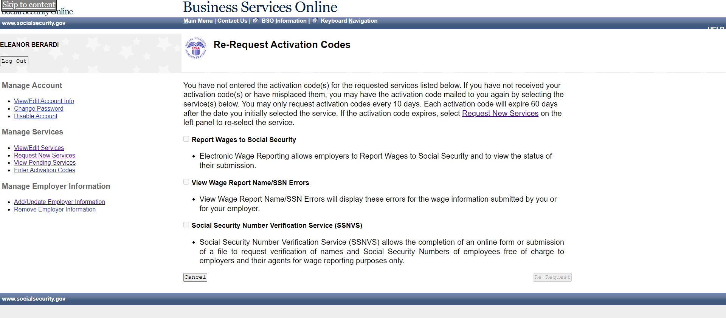

STEP 5: The actions you can take at this time will depend on when you last requested access to
a service.
- If it has not been at least 10 days since you requested the access to the service(s),
you will not be able to re-request your activation code(s) at this time.
- If it has been more than 60 days since you requested the access to the service(s),
you will need to re-request access to the service(s) by selecting the Request
Access to BSO Services link in the first paragraph of the current page.
- If it has been between 10 and 60 days since you requested the access to the
service(s), you may select the checkbox(es) of the service(s) and select the Re-
Request button. The system displays the View Pending Services – Confirmation
of Activation Code Notice Re-Request page.

(Select the Cancel button to return to the Business Services Online Main Menu without
re-requesting any activation codes. To return to the Business Services Online Main
Menu, select the BSO Main Menu link in the second line of the page header.)

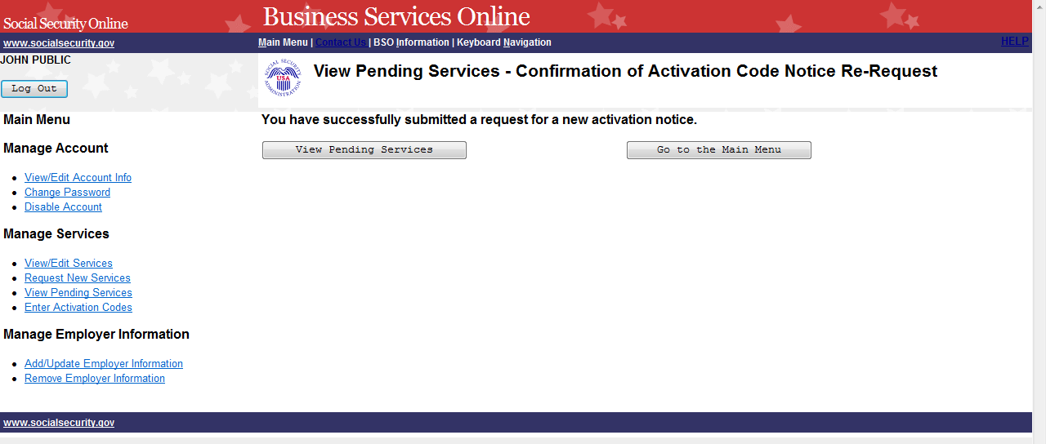

STEP 6: Select the View Pending Services button to return to the Re-Request Activation
Codes page. To return to the Business Services Online Main Menu, select the Go to
the Main Menu button.

LESSON 13: ENTER ACTIVATION CODE(S)

Follow the instructions below to enter the activation codes received by you directly or from your
employer. Certain services that you requested require you to enter an activation code before you
can use the online service.

STEP 1: Point your browser to the Business Services Online Welcome page: www.socialsecurity.gov/bso/bsowelcome.htm.

STEP 2: Select the Log in link on the Business Services Online Welcome page. The system
displays the Log in to Online Services page.

STEP 3: Under the Existing User? Column, enter your User ID and password (for AR, CBSV,
and IRPA only). Read the terms stated under the User Certification heading. You must
agree to these conditions by checking the “I have read & agree to these terms.”
Checkbox to proceed. Select the Log In button. The system displays the Business
Services Online Main Menu page. (To return to the Business Services Online Welcome
page, select the BSO Welcome link in the page footer.)

NOTE
The menu selection on your BSO Main Menu is unique to you and presents only the
applications and services to which you have access.

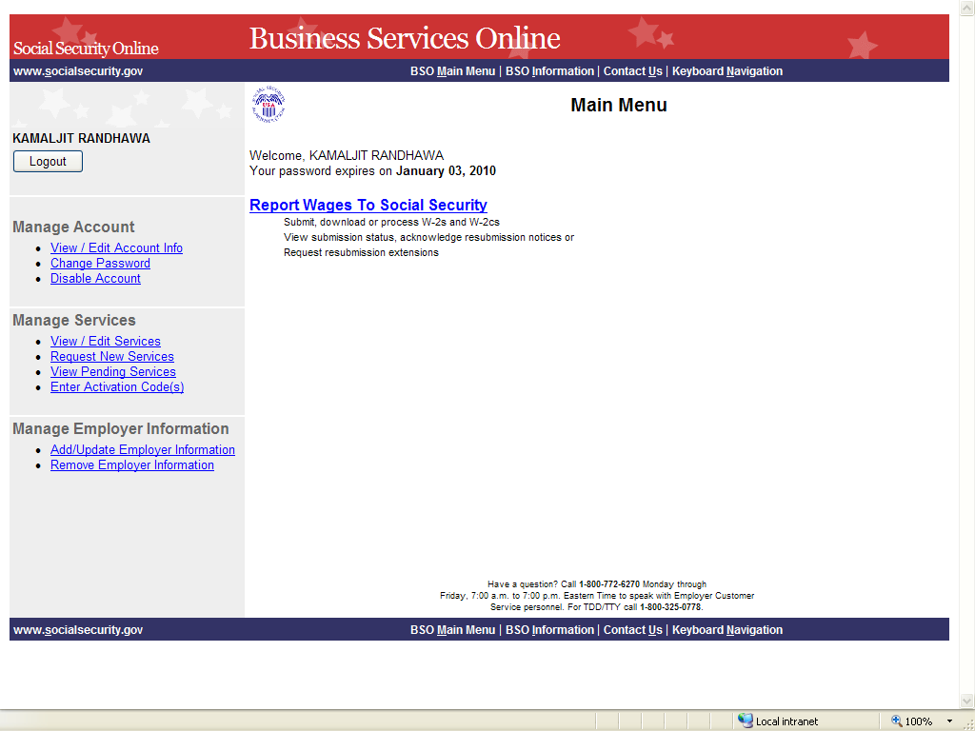

STEP 4: Select the Enter Activation Code(s) link on the left navigation panel. The system
displays the Enter Activation Code(s) page. (Select the Cancel button to return to the
Business Services Online Main Menu page without activating a service.)

NOTE
If you have more than one activation code to enter, repeat Steps 4 and 5.

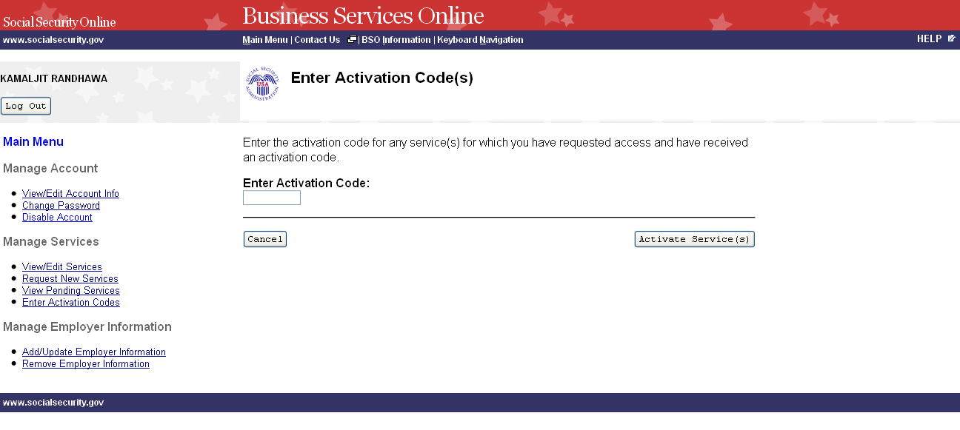
STEP 5: Enter the activation code in the Enter Activation Code field and select the Activate
Service(s) button. The system displays the Enter Activation Code(s) – Confirmation
page. (Select the Cancel button to return to the Business Services Online Main Menu
page without activating a service.)

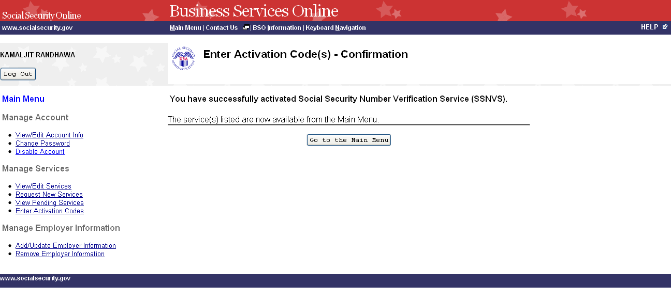
STEP 6: Select the Go to the Main Menu button to return to the Business Services Online
Main Menu page. The activated service will be listed.

LESSON 14: ADD EMPLOYER INFORMATION

Follow the instructions below to add employer information. Employer information is required in
order to request certain business services.

STEP 1: Point your browser to the Business Services Online Welcome page: www.socialsecurity.gov/bso/bsowelcome.htm.

STEP 2: Select the Log In button on the Business Services Online Welcome page. The system
displays the Log in to Online Services page.

STEP 3: Under the Existing User? Column, enter your User ID and password (for AR, CBSV,
and IRPA only). Read the terms stated under the User Certification heading. You must
agree to these conditions by checking the “I have read & agree to these terms.”
checkbox to proceed. Select the Log In button. The system displays the Business
Services Online Main Menu page. (To return to the Business Services Online Welcome
page, select BSO Welcome link in the page footer.)

NOTE
The menu selection on your BSO Main Menu is unique to you and presents only the
applications and services to which you have access.

STEP 4: Select the Add/Update Employer Information link from the left navigation panel. The
system displays the Employer Information Attestation page. (Select the Logout button to return
to the Business Services Online Welcome page.)

NOTE

Certain services require Employer information to have been added before you request
the service. If you have not previously added Employer information, the Request Access
to BSO Services page is re-displayed with the message “Employer Information is
required for the selected suite(s). Please select this link Add Your Employer
Information to continue.” When you select the link, the system displays the Employer
Information Attestation page.

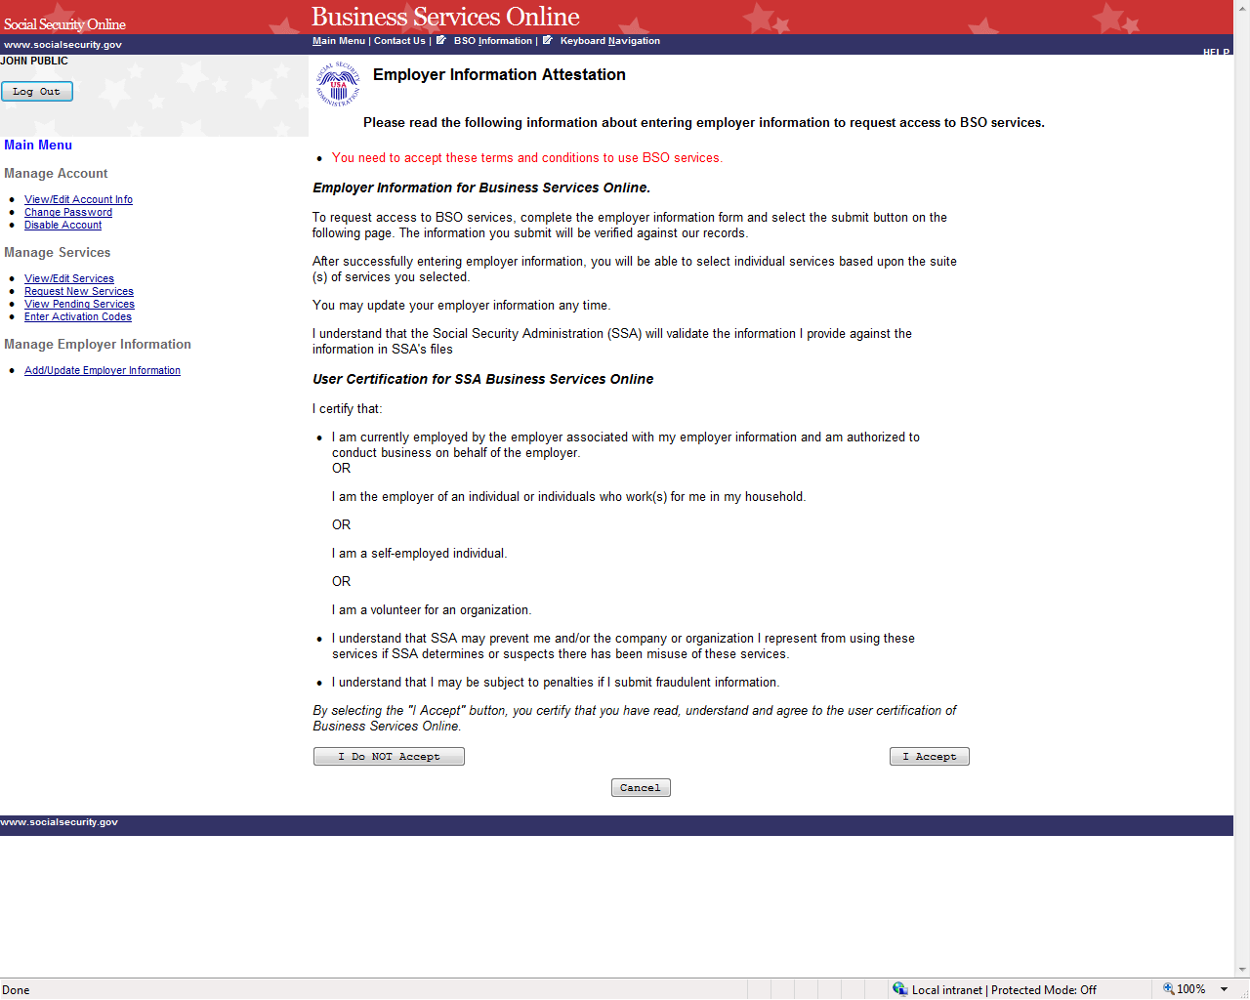

STEP 5: Read the statements located under the User Certification for Business Services Online
heading. You must agree to these terms by selecting the I Accept button to proceed.
The system displays the Add Employer Information page.

(Selecting the I Do NOT Accept button will display again the Employer Information
Attestation page with the message in red “You need to accept these terms and
conditions to use BSO services.”)

(Select the Cancel button to return to the Business Services Online Main Menu page.
To return to the BSO Welcome page, select the Log Out button.)

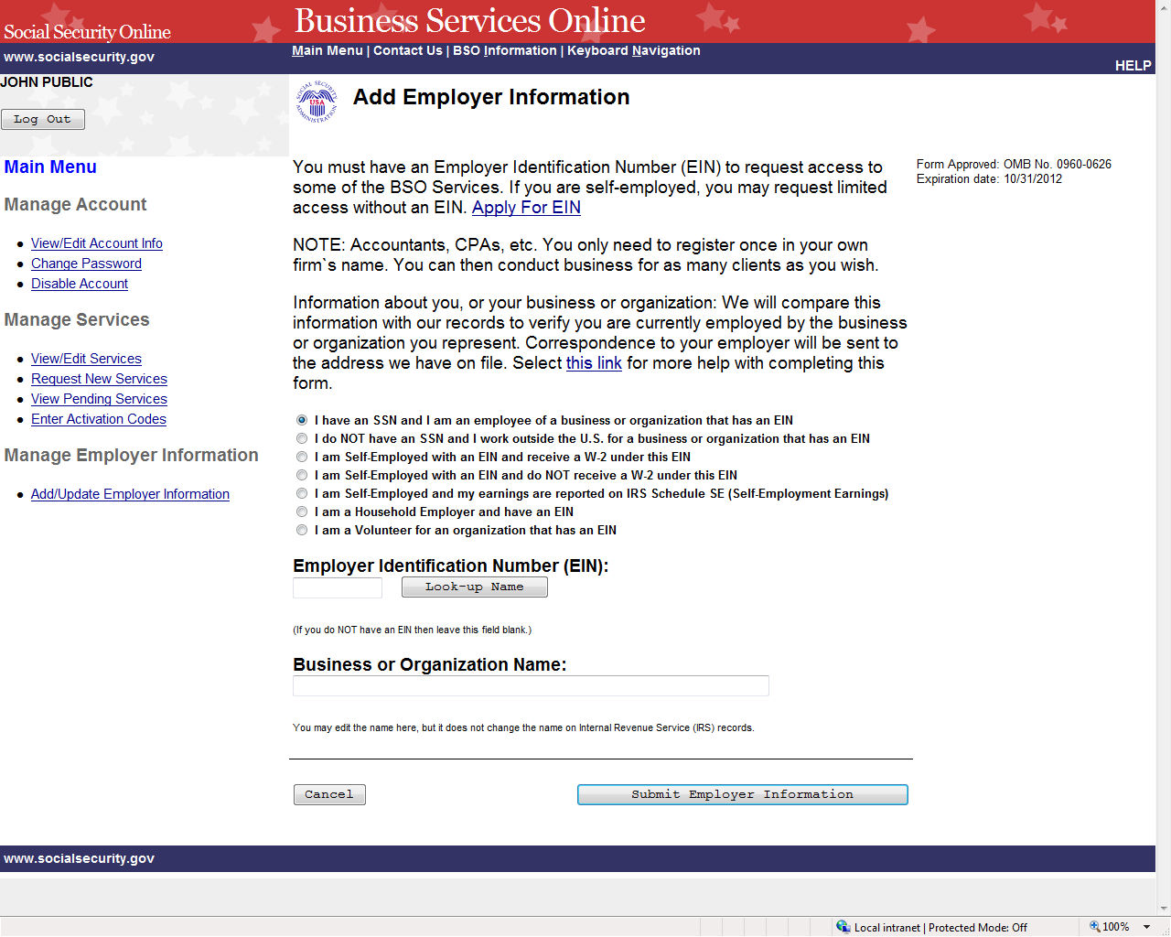

STEP 6: Select the radio button beside the description that best describes you and enter the
Employer Identification Number (EIN) and Business or Organization Name.

TIPS
- Do not enter dashes in the EIN.

- If you do not have an EIN, leave the EIN field blank.

STEP 7: The look-up button may be used to retrieve the name of the business or organization
that the IRS has provided to SSA to help you verify that the entered EIN is yours. You may edit
the name, but it does not change the name on Internal Revenue Service (IRS) records. Select the
Submit Employer Information button to process the employer information. The system displays
the Add Your Employer Information Successful page. (Select the Cancel button to return to the
Business Services Online Main Menu page. To return to the BSO Welcome page, select the Log
Out button.)

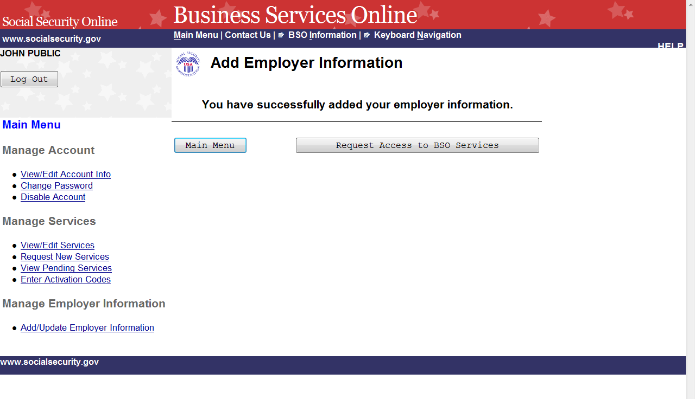
STEP 8: Select the Request Access to BSO Services button to select services you need to
access. The system displays the Request Access to BSO Services page. (Select the
Main Menu button to return to the Business Services Online Main Menu page. To
return to the BSO Welcome page, select the Logout link.)

LESSON 15: UPDATE EMPLOYER INFORMATION

Follow the instructions below to update employer information. To change your Employer
Identification Number (EIN) you must first "Remove Your Employer Information" which will
deactivate all active services with this employer and then re-request services by selecting the
Request New Services link under the Manage Services section on the left navigation panel.

STEP 1: Point your browser to the Business Services Online Welcome page: www.socialsecurity.gov/bso/bsowelcome.htm.

STEP 2: Select the Log In button on the Business Services Online Welcome page.

NOTE
The menu selection on your BSO Main Menu is unique to you and presents only the
applications and services to which you have access.

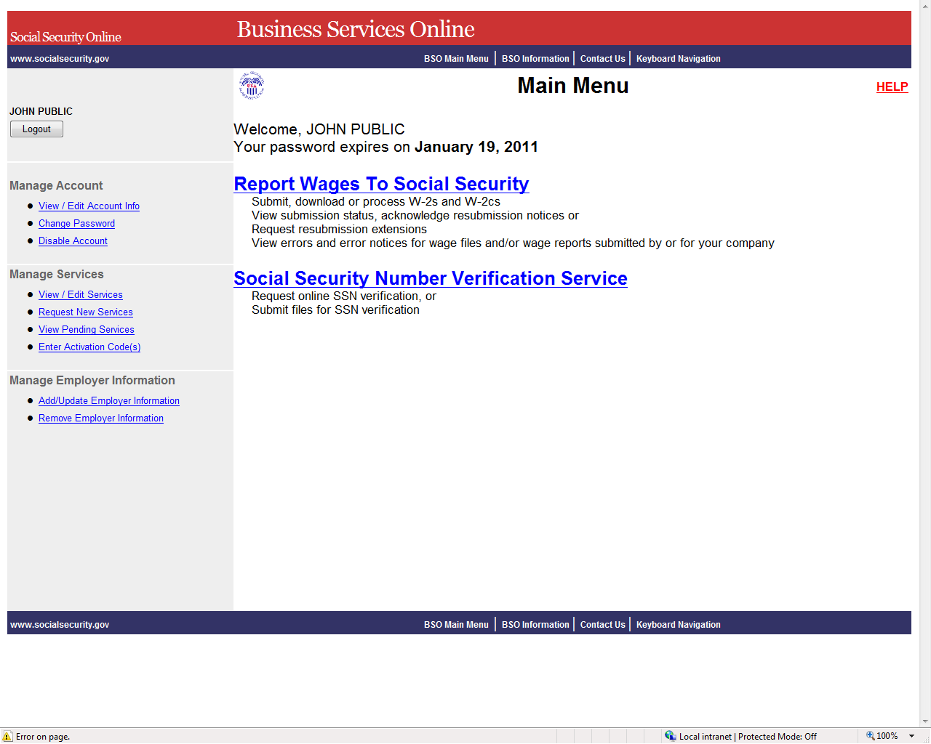

STEP 3: Select the Add/Update Employer Information link from the left navigation panel. The
system displays the Update Your Employer Information page. (Select the Logout button to return
to the Business Services Online Welcome page.)

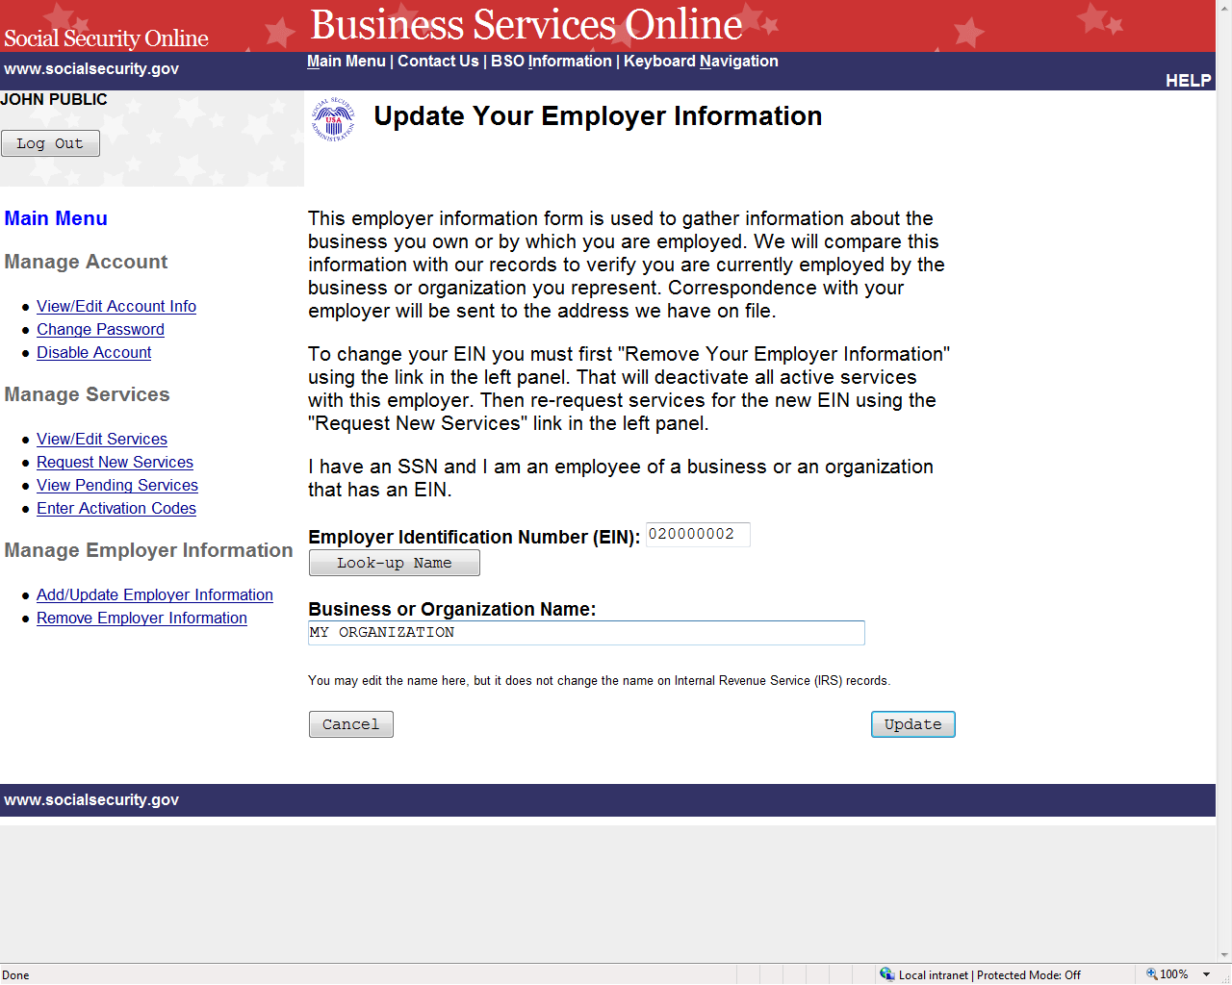

STEP 4: Change any information and select the Update to submit the changes. The system
displays the Update Your Employer Information Successful page. (Select the Cancel
button to return to the Business Services Online Main Menu page without submitting
any changes).

NOTE
Changing the EIN will deactivate all active services with this employer. To request
services for this different employer, select the Request New Services link under the
Manage Services section on the left navigation panel.

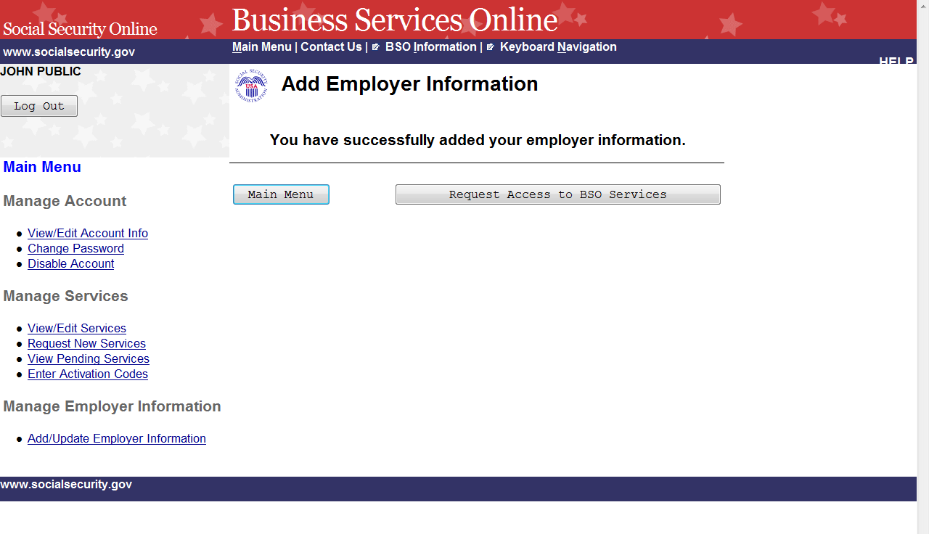

STEP 5: Select the Main Menu button to return to the Business Services Online Main Menu.

LESSON 16: REMOVE EMPLOYER INFORMATION

Follow the instructions below to remove employer information. Removing this employer
information will cause the services for this employer to be deactivated.

STEP 1: Point your browser to the Business Services Online Welcome page: www.socialsecurity.gov/bso/bsowelcome.htm.

STEP 2: Select the Log In button on the Business Services Online Welcome page.

NOTE
The menu selection on your BSO Main Menu is unique to you and presents only the
applications and services to which you have access.

STEP 3: Under the Manage Employer Information section of the left navigation panel, select
the Remove Employer Information link. The system displays the Remove Your Employer
Information page. (Select the Logout button to return to the Business Services Online Welcome
page.)

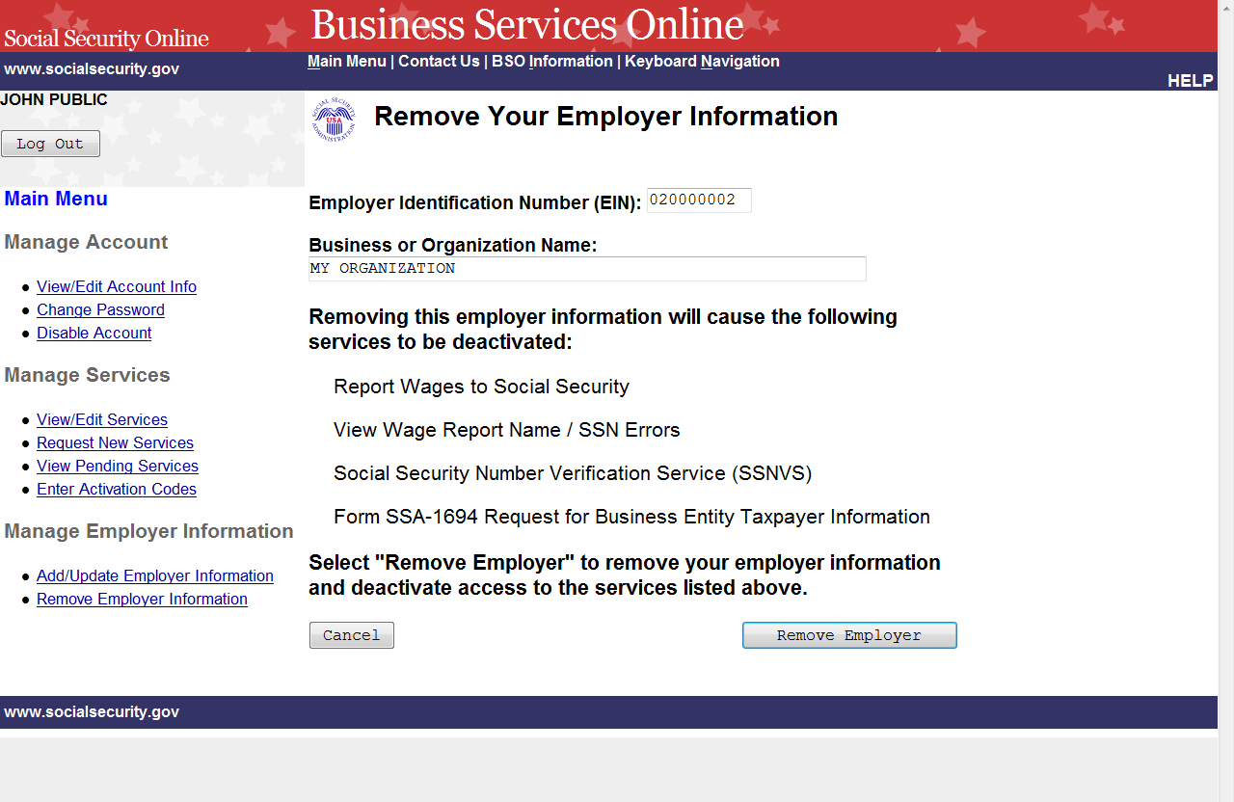

STEP 4: Select the Remove Employer button to submit the changes. The system displays the
Remove Your Employer Information Successful page. (Select the Cancel button to
return to the Business Services Online Main Menu page without removing the
employer.)
NOTE
Removing this employer information will cause the listed services to be deactivated.

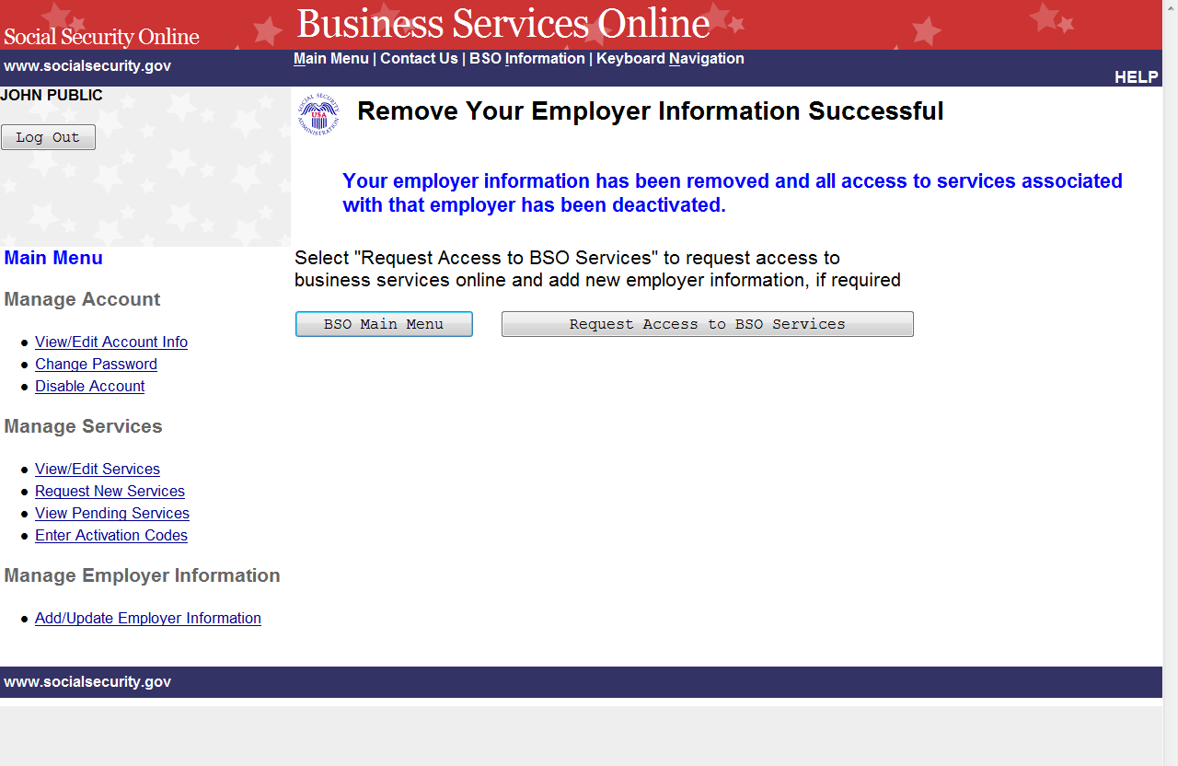

STEP 5: Select the Request Access to BSO Services button to request new services for a
different employer. To return to the Business Services Online Main Menu, select the BSO Main
Menu button.

